Senior Videographer, Ironwood Pictures, Philadelphia, PA
2017 – 2021

RED V-Raptor, ARRI Mini LF Sony Venice, FX9
KEY SKILLS
Cooke and Zeiss cinema lens sets
ARRI SkyPanel and large-format lighting
DaVinci Resolve grading Crew leadership (up to 15) Bidding and scoping
Camera report and on-set protocols Mentorship and operator training FAA Part 107 drone license
SAG and IATSE working knowledge
- Lead shooter on documentary features and branded long-form for streaming and festival release.
- Operated A-cam on a feature doc that premiered at SXSW and was acquired for streaming distribution.
- Built lighting and lens packages tuned to small-doc footprints (3-person crew, 2-ton truck).
- Cut down post hand-off issues by writing a camera report SOP adopted across all field crews.
- Trained 5 junior shooters on doc coverage discipline and interview lighting.

- Videographer, Bayline Media Group, Jersey City, NJ
2014 – 2017

  - Shot and edited corporate, recruiting, and event content for Fortune 1000 clients.
  - Operated multi-cam interview setups with teleprompter and IFB.
  - Edited in Premiere Pro and finished in After Effects for motion graphics handoff.
  - Grew personal day rate 65% over three years through reel-driven client referrals.

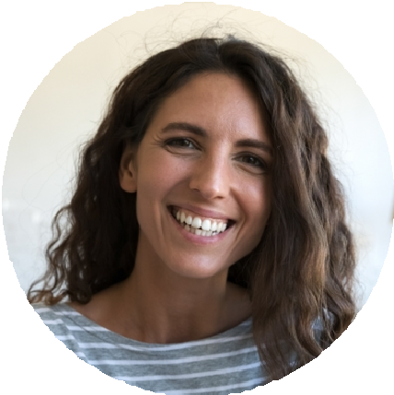



M.F.A. Cinematography, AFI Conservatory, 2014
B.A. Communications, Rutgers University, 2011
HANNAH VASQUEZ
Videographer
Senior videographer and DP with 12+ years across commercial, documentary, and
broadcast. Lead crews up to 15, own creative through delivery, and bring a producer's eye to bidding and scoping.
PROFESSIONAL EXPERIENCE
Director of Photography, Atlas Pier Films, Brooklyn, NY
2021 – Present

Lead DP across 6 to 8 commercial campaigns a year for CPG, fashion, and finance clients.
Headed a 14-person crew on a national bank spot that ran in 3 markets for
$1,250,000 in placed media.
Spec, bid, and crew RED V-Raptor and ARRI Mini LF packages; manage rental and insurance flow with production.
Mentor two staff operators into DP slots, freeing senior bandwidth for client pitches.
Sit in on agency scope calls to push back on schedules that would compromise the shoot.
EDUCATION

(917) 558-3402

hannah.vasquez@example.com Brooklyn, NY 12345
CONTACT INFORMATION
    - Camera Operator, Riverstone Broadcast Services, Newark, NJ
2012 – 2014

Operated studio and field cameras for regional sports and live event broadcasts.
Pulled focus and handled jib operation on weekly multi-cam shows.
Built familiarity with live switching, intercom, and broadcast color discipline.

Stepped into A1 audio on short-notice coverage 6 times a quarter.

