MARCUS DELGADO
Coaching
Head boys' basketball coach with 9 seasons developing high school athletes into conference contenders and college recruits. Built programs that pair ﬁlm-room rigor with academic accountability, sending 14 players to NCAA rosters since 2019. Known for retention, parent communication, and offensive systems built around the personnel on hand.
PROFESSIONAL EXPERIENCE

C O N T A C T
I N F O R M A T I O N

(919) 555-0142

marcus.delgado@email.com Raleigh, NC

K E Y S K I L L S
2019 - Present
Head Boys' Basketball Coach | Pine Hollow High School, Raleigh, NC

Lead varsity program of 14 players plus JV and freshman levels; oversee 4 assistant coaches and a strength staff.
Posted a 127-38 record over ﬁve seasons with three conference titles and two regional ﬁnals appearances.
Placed 9 seniors on NCAA Division I or II rosters by building individualized recruiting plans starting sophomore year.
Cut team turnovers per game from 18 to roughly 11 by installing a half-court read-and-react offense.
Run mandatory study hall four nights per week; team GPA has stayed above 3.2 every semester since 2021.




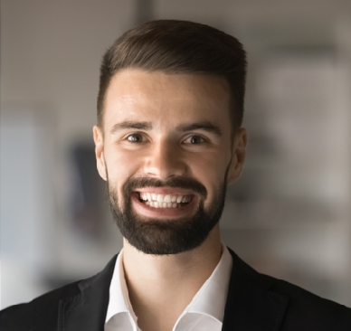
Half-court offensive system design and read-and-react concepts
Defensive scheming including pack-line and ball-screen coverages
Film breakdown and opponent scouting using Hudl and Synergy
College recruiting strategy and coach outreach for D1 and D2 placement
Player development plans tailored by position and grade level
Practice planning and seasonal periodization
Parent communication and program culture building
Staff management and assistant coach development
Academic accountability systems and study hall coordination
Strength and conditioning collaboration
Budget management for travel, equipment, and summer programming
AAU and offseason competitive scheduling
2016 - 2019
Assistant Varsity Coach, Boys' Basketball | Westbrook Academy, Durham, NC

Ran post player development and rebounding schemes for a program that reached the 3A state semiﬁnal in 2018.
Built ﬁlm breakdowns for opponent scouting using Hudl, delivering one-pagers to the head coach each Sunday.
Coordinated summer AAU partnerships that brought 6 returning players into year-round competitive reps.
Mentored two assistants who went on to head coaching roles at the middle school level.

2014 - 2016
Physical Education Teacher and JV Coach | Carver Middle School, Cary, NC

Coached 7th and 8th grade boys' basketball, ﬁnishing 22-4 across two seasons.
Taught ﬁve PE sections daily with emphasis on movement literacy and small-sided games.
Started a girls' open gym that grew from 8 participants to a regular group of 30 by year two.
EDUCATION
M.Ed. in Sport Administration, North Carolina State University, 2016

B.S. in Physical Education and Health, East Carolina University, 2013 NFHS Coaching Certiﬁcation, Levels 1 and 2
USA Basketball Gold License, renewed 2023

CPR, First Aid, and AED Certiﬁcation, American Red Cross

