Betty Harris

Barista Resume
Hospitality student and part-time barista with 14 months behind the bar in a campus-adjacent cafe. Comfortable on a two-group automatic machine, steady on milk steaming, and quick to learn drink builds. Looking to move into a full-service specialty coffee role after graduation in May.

Contact information

(850) 233-9041

Professional experience
Barista | Magnolia Bean Cafe, Tallahassee, FL 2023 - Present

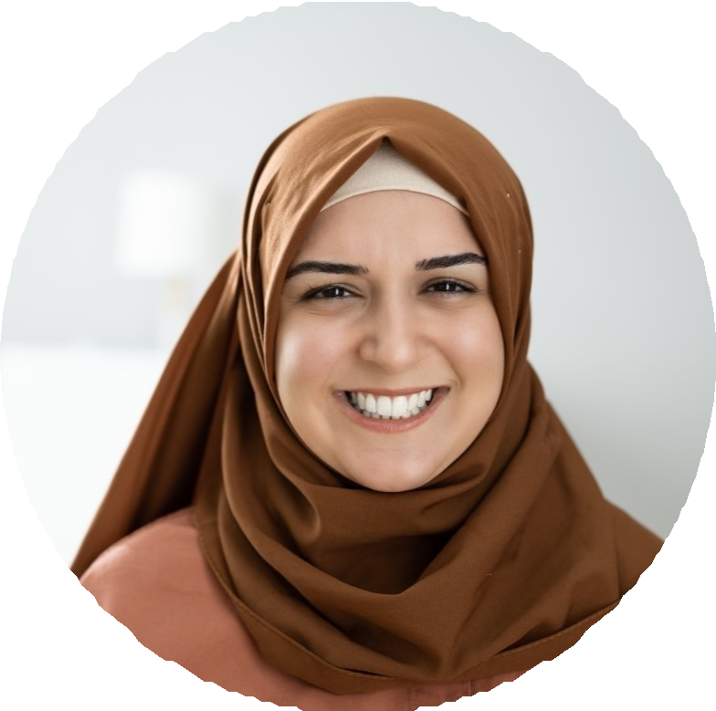



devon.asare@example.com Tallahassee, FL 12345

Education

B.S. Hospitality Management, Florida State University, expected May 2025

ServSafe Food Handler Certiﬁcation, 2023

Key skills

Espresso drinks and milk steaming
Nuova Simonelli Appia II Clover POS and cash handling
Batch brew and pour-over basics
Customer service and order accuracy
ServSafe food handling Opening and closing duties Basic latte art (heart, tulip)
Pull 180-240 espresso shots per shift on a Nuova Simonelli Appia II and steam milk for lattes, cappuccinos, and flat whites
Ring guests through Clover POS, handling roughly $1,400 in daily sales without a drawer variance over $2 in 9 months
Restock pastry case, brew batch drip every 45 minutes, and run dishwasher cycles between rush waves
Earned 'Barista of the Month' once for covering 6 open shifts during finals week

Cashier and Food Runner | Sunset Smoothie Bar, Tallahassee, FL 2022 - 2023
Took orders, blended smoothies, and bussed tables across lunch shifts seating 35 guests
Cross-trained on register and back-of-house prep within 3 weeks of hire Kept fruit and yogurt par sheets current to cut weekly waste

