Christopher Taylor

Professor

Full Professor and former department chair in molecular biology with 22 years on the tenure ladder. PI on continuous NIH R01 funding since 2009, with 94 peer-reviewed publications and 3 issued patents. Elected fellow of the American Academy of Microbiology.

CONTACT INFORMATION
PROFESSIONAL EXPERIENCE

 (919) 555-0119

e.whitﬁeld@email.com
PROFESSOR OF MOLECULAR BIOLOGY | CAROLINA HEIGHTS UNIVERSITY, CHAPEL RIDGE, NC

2015 – PRESENT

 Chapel Ridge, NC 12345

EDUCATION

PhD in Molecular Biology, Yale University, 1999

BS in Biochemistry, summa cum laude, University of Michigan, 1993

KEY SKILLS
Direct a 14-person lab studying ribosomal regulation in bacterial pathogens; current NIH R01 portfolio totals $2.4M in active direct costs
Served as department chair from 2018 to 2023; hired 7 tenure-track faculty and grew sponsored research expenditures by roughly 45%
Senior author on 38 papers since promotion, including 6 in Cell, Molecular Cell, and PNAS
Chair the institutional review committee for the campus biosafety program
Mentor 5 doctoral students and 3 postdocs; trainees have moved into faculty roles at MIT, Duke, and the NIH

ASSOCIATE PROFESSOR OF MOLECULAR BIOLOGY | CAROLINA HEIGHTS UNIVERSITY, CHAPEL RIDGE, NC
2009 – 2015

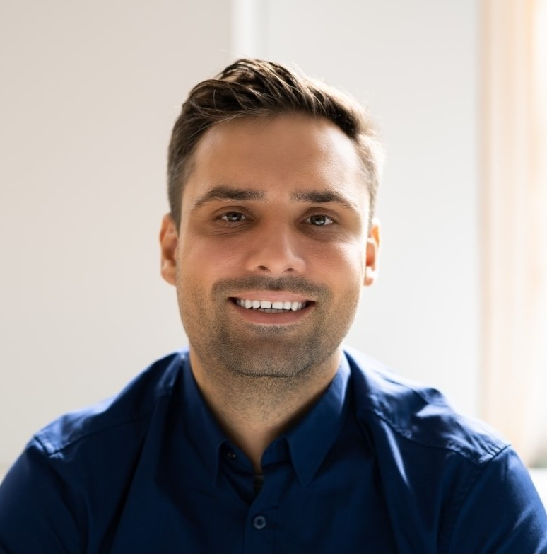
NIH grant writing (R01, R21, P01) and study section review
Bacterial genetics and ribosome biology
Cryo-EM and X-ray crystallography of macromolecular complexes
CRISPR-Cas9 genome editing in microbial systems
RNA-seq, ribosome proﬁling, and computational data analysis
Laboratory leadership and PhD/postdoc mentorship
Departmental administration and faculty recruitment
Peer review for Cell, Nature Microbiology, and PNAS
Graduate and undergraduate curriculum development
Biosafety oversight (BSL-2 and BSL-3 protocols)
Scientiﬁc advisory board service and industry collaboration
Earned tenure in 2012 and promotion to Associate Professor in 2013 Secured ﬁrst R01 award in 2009 and a competing renewal in 2014
Co-founded the campus structural biology core facility, now serving 40+ labs
Graduated 4 PhD students during this period
Awarded Pew Scholar in the Biomedical Sciences (2010)

ASSISTANT PROFESSOR OF MOLECULAR BIOLOGY | CAROLINA HEIGHTS UNIVERSITY, CHAPEL RIDGE, NC
2003 – 2009

Built the Whitﬁeld Lab from a startup package of approximately $850,000
Published ﬁrst independent papers in Molecular Microbiology and Journal of Bacteriology
Trained 2 graduating PhD students and 6 undergraduate researchers
Taught BIO 410 (Microbial Genetics) and a graduate seminar on antibiotic resistance

POSTDOCTORAL FELLOW | HARVARD MEDICAL SCHOOL, BOSTON, MA 1999 – 2003
NIH F32 postdoctoral fellow in the lab of Dr. Susan Park

Conference organization and invited keynote presentation

First-authored paper in Cell on ribosomal rescue pathways (2002) Mentored 3 rotating graduate students through the BBS program
Presented at the annual Cold Spring Harbor Molecular Genetics of Bacteria and Phages meeting

