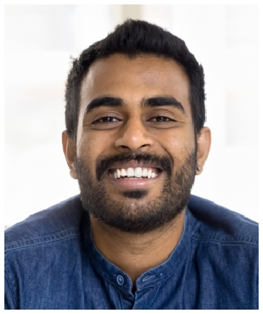

Contact information
JORDAN
OKONKWO
Event Manager

Director of events with 14 years building global event programs at high-growth B2B companies. Own portfolios of $7M-$11M, lead teams of 9-12, and set the strategy for flagship user conferences of 5,000+ attendees. Track record of tying events to pipeline, retention, and brand.
 (612) 555-0167
 jordan.okonkwo@example.com  Minneapolis, MN 12345

Education
M.B.A., MARKETING, UNIVERSITY OF WISCONSIN-MADISON, 2014
B.A., ENGLISH, MACALESTER COLLEGE, 2010
CMP, EVENTS INDUSTRY COUNCIL, 2016

Professional experience
DIRECTOR, GLOBAL EVENTS | VERDANTAGE CLOUD, MINNEAPOLIS, MN | 2021 - PRESENT

Own a $9.6M global event portfolio across user conference, regional summits, trade shows, and exec programs.
Lead a team of 11 (3 managers, 6 coordinators, 2 producers) plus a
$1.8M agency roster.
Grew ﬂagship user conference from 3,400 to 5,900 attendees in 3 years while holding cost per attendee ﬂat.
Built attribution model with RevOps showing events sourced or inﬂuenced 31% of new ARR last ﬁscal year.
Reset sponsorship pricing tiers, lifting sponsor revenue from $1.2M to
$2.6M across two cycles.

Key skills
Portfolio strategy $7M-$11M
Team leadership (9-12 staff)
Attribution and pipeline modeling
Sponsorship monetization
Master vendor agreements
Customer advisory boards
Cvent enterprise admin
Salesforce + Tableau reporting
Agency management
Crisis and contingency planning
Executive stakeholder management
International event production

HEAD OF FIELD AND CUSTOMER EVENTS | HARTWELL INDUSTRIAL SOFTWARE, ST. PAUL, MN | 2018 - 2021

Stood up the ﬁrst dedicated events team (7 hires) inside a Series D company scaling from 400 to 1,100 employees.
Designed a 5-region ﬁeld event calendar covering 60+ touchpoints per year.
Owned the customer advisory board program for 28 enterprise accounts.
Negotiated the company's ﬁrst multi-year convention center master agreement in Chicago.
Cut average event production cycle from 16 weeks to 11 by standardizing brief templates.

SENIOR EVENT MANAGER | CRESTERLY FINANCIAL GROUP, MADISON, WI | 2014 - 2018

Produced annual investor day for 350 LPs and a partner roadshow across 7 cities.
Managed compliance review for all speaker decks and event collateral.
Ran sponsorship sales for the ﬁrm's industry summit, closing about $740K per cycle.
Mentored 4 coordinators, 3 of whom were later promoted to manager.

EVENT MANAGER | OAKBRIDGE STRATEGY CONSULTING, MILWAUKEE, WI
| 2011 - 2014

Planned executive workshops and client offsites in 14 US cities and 3 European cities.
Managed travel and visa coordination for partner-level attendees.
Built the ﬁrm's ﬁrst vendor scorecard used to consolidate from 38 to 12 preferred suppliers.
Owned post-event survey program and quarterly client experience report.

