Justin Parker
Librarian

Academic librarian with 9 years of instruction, reference, and electronic resources experience at a regional comprehensive university. Liaison to nursing and social work; teach around 70 information literacy sessions a year.
Comfortable with assessment, LibGuides at scale, and vendor negotiations.
PROFESSIONAL EXPERIENCE

CONTACT INFORMATION

(253) 555-0167

priya.ramanathan@email.co m

Tacoma, WA 12345

KEY SKILLS
2021 - Present
Health Sciences Liaison Librarian | Cascade Sound University Library, Tacoma, WA
- Teach information literacy and evidence-based practice sessions for BSN, MSW, and DNP programs, reaching about 1,250 students per academic year.
- Embedded librarian in 6 Canvas courses; built scaffolded research modules tied to ACRL Framework outcomes.
- Renegotiated a CINAHL Complete renewal and saved the library $18,400 in year-one cost with no loss of full-text titles.
- Co-chair the library's DEI collection audit; flagged gaps in disability studies and Indigenous health resources.
- Mentor a rotating MLIS practicum student each semester.

ACRL Framework instruction
Systematic search support (PubMed, CINAHL, PsycINFO)
Canvas and embedded librarianship
LibGuides CMS and LibInsight
Electronic resource management
Vendor negotiation and licensing
Citation management (Zotero, EndNote)
Assessment and rubric design Collection development
2018 - 2021
Reference and Instruction Librarian | Northshore Community College Library, Bellingham, WA
Taught 40-50 one-shot instruction sessions per term for English 101 and allied health programs.
Redesigned 22 LibGuides into a template-based model that cut maintenance time roughly in half.
Managed the streaming media collection (Kanopy, Films on Demand) and tracked usage against per-view cost.
Served on the open educational resources committee; supported 5 faculty in adopting OER textbooks.
2016 - 2018
Reference Librarian (Part-Time) | Pierce County Library System, Lakewood, WA
Staffed the adult reference desk weekends and two evenings a week at a busy suburban branch.
Ran a monthly job-search drop-in clinic covering resumes, LinkedIn, and state WorkSource resources.
Trained 3 new pages on shelving accuracy and patron privacy at the desk.

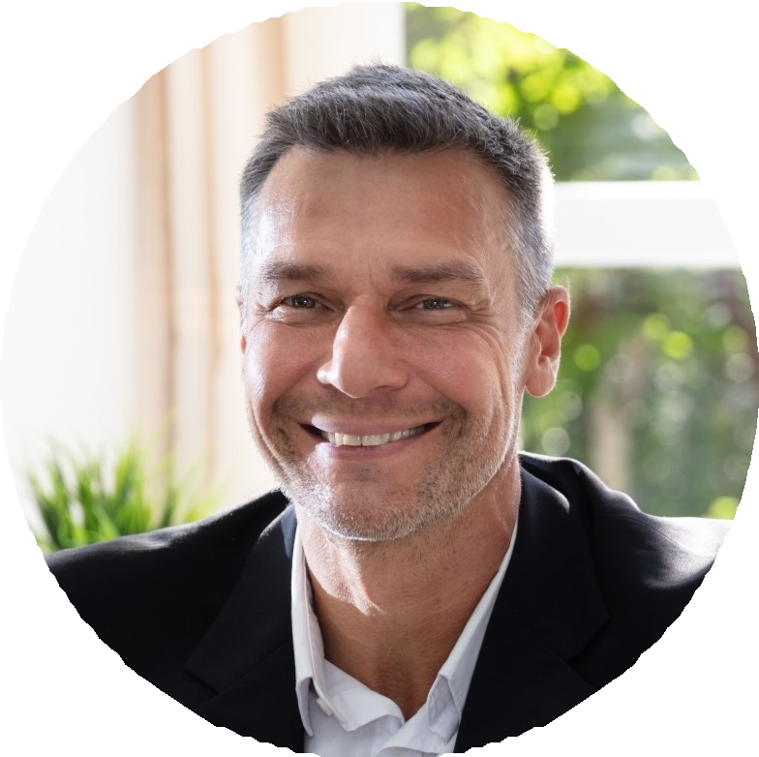


EDUCATION
MLIS, University of Washington Information School, 2016 BA in Public Health, Western Washington University, 2014

