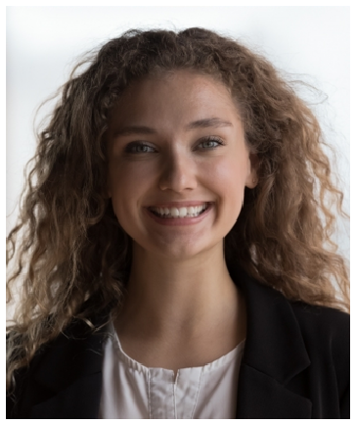

Contact information
DANIELA
RESTREPO
Camp Counselor

Camp counselor with seven summers across residential, day, and specialty camps, the last three as a Unit Leader. Strong record building counselor teams, handling parent escalations, and running outdoor education programming for groups of 80+ campers.
Currently pursuing ACA Camp Director credential.
 (828) 555-0119
 daniela.restrepo@example.com  Asheville, NC 12345

Education
B.S. IN OUTDOOR RECREATION MANAGEMENT, APPALACHIAN STATE UNIVERSITY, 2020
ACA CAMP DIRECTOR COURSE (IN PROGRESS), EXPECTED 2025
CERTIFICATIONS: WILDERNESS FIRST RESPONDER (WFR), LIFEGUARD, CPR/AED, MENTAL HEALTH FIRST AID

Key skills
Unit leadership and staff supervision
Counselor coaching and performance feedback
Risk management and incident response
Trauma-informed care
Parent communication and escalation handling
Backcountry trip planning and Leave No Trace
Program design for ages 8-15
Inclusion planning with support teams
Bilingual: English / Spanish

Professional experience
UNIT LEADER, TRAILBLAZERS (AGES 11-13) | BLUE HOLLOW MOUNTAIN CAMP, BLACK MOUNTAIN, NC | SUMMERS 2022 - PRESENT

Manage a unit of 84 campers and 12 counselors across six cabins for the full 9-week residential season
Rebuilt the unit's evening program rotation, cutting end-of-day behavior incidents from roughly 4 per week down to 1
Run weekly counselor coaching sessions and write mid-season performance check-ins for each staff member
Serve as the on-call point of contact for parent calls about homesickness, conﬂict, or medical concerns within the unit
Co-led the 2024 staff training on trauma-informed care with the camp's mental health director

BACKPACKING TRIP LEADER | CASCADE PINES WILDERNESS CAMP, BEND, OR | SUMMERS 2020 - 2021

Led 5- to 8-day backcountry trips for groups of 10 campers ages 13-15 through the Three Sisters Wilderness
Completed pre-trip risk assessments, meal planning for 11 people, and gear shakedowns before each departure
Handled one evacuation for suspected appendicitis, coordinating with base camp and SAR; camper reached hospital in under 6 hours
Trained four new trip leaders on Leave No Trace ethics, bear-bag protocol, and group dynamics on long trail days
Wrote post-trip reports ﬂagging two trail sections needing reroute due to washouts

SENIOR COUNSELOR | WILLOW CREEK ARTS CAMP, LEXINGTON, KY | SUMMERS 2018 - 2019

Supervised cabin of 12 campers ages 9-11 and co-taught daily printmaking and ceramics studios
Adapted studio activities for two campers with sensory processing differences in coordination with the inclusion team
Planned all-camp talent show with the program director, coordinating 38 acts and a 90-minute run of show
Mentored two ﬁrst-year counselors through their hardest week, both returned the following summer

JUNIOR COUNSELOR | RIVERBEND YMCA DAY CAMP, KNOXVILLE, TN | SUMMERS 2016 - 2017

- Assisted lead counselor with a group of 16 rising third graders during 9-week summer programming
- Ran daily check-ins, attendance, and swim buddy checks at the pool
- Earned 'Counselor of the Week' recognition twice during the 2017 season

