HYEJIN PARK
Translator

A B O U T M E

C O N TA C T I N F O R M AT I O N
Korean-English translator with two years of internship and freelance experience in gaming localization and academic translation. Comfortable in Phrase and memoQ. Looking for a junior translator role with a localization team.

(612) 555-0149

hyejin.park@example.com Minneapolis, MN 12345

E D U C AT I O N

B.A. Korean and Linguistics, University of Minnesota, 2023

Coursera Game Localization Specialization, 2023

P R O F E S S I O N A L E X P E R I E N C E

LOCALIZATION INTERN (KOREAN-ENGLISH) | PIXELGROVE STUDIOS, MINNEAPOLIS, MN
2023 - PRESENT

Translated in-game dialogue, UI strings, and patch notes for a mid-size mobile RPG, averaging 6,500 words per week.
Logged 380 terminology decisions to the studio glossary in Phrase, including honoriﬁc style rules for player-facing copy.
Sat in on weekly LQA reviews with the QA team and applied feedback to next-build strings.
Wrote translator notes for ambiguous source lines so reviewers could decide.




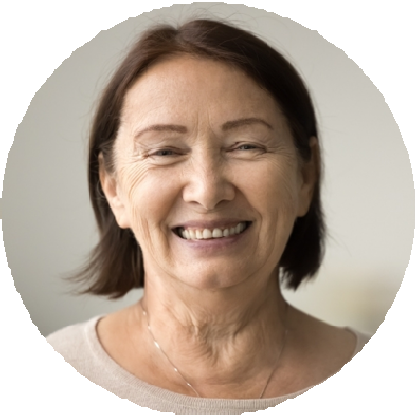
ATA Student Member

K E Y S K I L L S

Language pairs: KO<>EN (native KO)
CAT tools: Phrase, Trados Studio, memoQ (basic)
Game localization: dialogue, UI, patch notes
Glossary and style guide use MT post-editing (DeepL) Google Workspace, Notion Familiar with Crowdin
FREELANCE TRANSLATOR | SELF-EMPLOYED, REMOTE
2022 - 2023

Translated abstracts and conference papers for graduate students in linguistics and education, roughly 40,000 words total.
Delivered all 23 projects on or before deadline with zero rework requests. Used Trados Studio trial license and built personal TM from scratch.

