AISHA COLEMAN
M S W , L C S W

Licensed clinical social worker with 6 years of case management across pediatric oncology and adult behavioral health. Known for steady caseload management, clean documentation, and strong relationships with families navigating long treatment timelines. Bilingual English and French.

CONTACT INFORMATION

(919) 663-8842

PROFESSIONAL EXPERIENCE

Senior Case Manager | Piedmont Children's Cancer Center, Raleigh, NC | February 2022 – Present

aisha.coleman@email.com

Linkedin.com/in/aishacoleman-msw

Raleigh, NC, Tulsa, OK 12345

KEY SKILLS
Psychosocial assessment and biopsychosocial documentation
Person-centered treatment planning and goal setting
Crisis intervention and safety planning
Motivational interviewing and trauma-informed care
Care coordination across medical, behavioral, and community resources
Insurance navigation, prior authorizations, and patient assistance programs
Electronic health records (Epic, Cerner) and REDCap data tracking
HIPAA, CARF, and Joint Commission documentation standards
Interdisciplinary team collaboration and case presentation
Clinical supervision of MSW interns
Bilingual English and French client communication
Group facilitation (relapse prevention, psychoeducation)
Manage a caseload of 34 active pediatric oncology patients and their families from diagnosis through survivorship transition
Coordinate lodging, transportation, and school re-entry; processed $86,400 in patient assistance fund awards in 2024
Lead weekly psychosocial rounds with oncology, child life, and chaplaincy, presenting two to four complex cases each week
Built a tracking dashboard in REDCap that cut missed ﬁnancial assistance deadlines from a handful per quarter to zero over three quarters
Supervise one MSW intern each semester and co-teach the program's onboarding module on grief and loss

Behavioral Health Case Manager | Cardinal Wellness Partners, Durham, NC | September 2019 – January 2022

Carried a panel of 55 to 65 adult clients with co-occurring SUD and serious mental illness in an outpatient setting
Coordinated medication-assisted treatment with prescribers and tracked appointment adherence, retaining about three-quarters of the panel in treatment at
6 months
Wrote person-centered treatment plans and 90-day reviews that passed two consecutive CARF audits with no ﬁndings
Facilitated a weekly relapse prevention group of 8 to 12 members

Case Manager | Triangle Family Services, Cary, NC | June 2018 – August 2019

Conducted home visits for families referred from CPS, completing safety plans and connecting parents to parenting classes and substance use treatment
Maintained a caseload of about 22 families with documentation submitted on time in 94% of audits
Testiﬁed in juvenile court on three cases during the year

EDUCATION

Master of Social Work (MSW), Clinical Concentration
University of North Carolina at Chapel Hill | May 2018

Bachelor of Arts in Psychology
North Carolina State University | May 2016

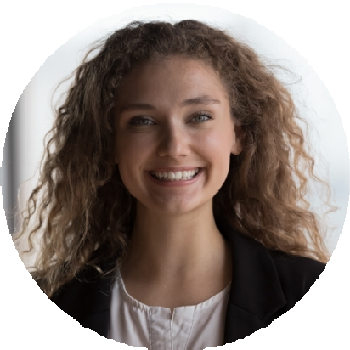




Licensed Clinical Social Worker (LCSW), North Carolina Social Work Certiﬁcation and Licensure Board, 2021

Certiﬁed Case Manager (CCM), Commission for Case Manager Certiﬁcation, 2022

