MARCUS TOLBERT

Copywriter

Creative director with 17 years leading copy-led teams across agency, in-house, and consultancy environments. Built and run pods of 8 to 22 writers and designers serving Fortune 500 brands in tech, automotive, and QSR. Equally comfortable in the pitch room, the edit bay, and a Q4 budget review.

Location
Austin, TX

Phone
(512) 887-4421

Email
marcus.tolbert@example.com

Education

B.A., Journalism, Northwestern University, 2007

VCU Brandcenter, Copywriting Track, 2009

Key Skills
Creative department leadership
P&L and account growth
Hiring and team development
Brand platforms and positioning
Integrated campaign vision
New business pitching
Production oversight
C-suite partnership
Agency operations
Coaching ACDs and CDs

Professional Experience
Group Creative Director, Verdane Creative Partners, Austin, TX
2020 - Present

Run a 22-person creative department across two ofﬁces, with annual billings of roughly
$18M.
Led the global launch of an EV sub-brand, with the hero ﬁlm earning 47M paid views and lifting test-drive bookings by 22% in the launch market.
Rebuilt the agency's creative review process, shaving an average of 11 days off campaign turnaround.
Won and grew the QSR account from a single project into a retainer worth $4.2M in year two.
Hired and developed three associate creative directors, two promoted from senior copywriter inside 18 months.

Executive Creative Director, In-House, Lumitrace Software, Austin, TX
2017 - 2020

Built the in-house creative function from three contractors to a 14-person team covering brand, campaigns, and product marketing.
Owned voice and creative for an IPO roadshow that contributed to a $1.6B raise.
Set the brand system and launch campaign for a new developer product line that hit ARR targets two quarters early.
Partnered with the CMO on annual marketing planning and presented creative at four board meetings.
Cut external agency spend by about a third by bringing campaign work in-house.

Creative Director, Holloway & Pike, Chicago, IL
2014 - 2017

Led copy and concept on accounts in ﬁnance, telecom, and CPG, with a creative pod of eight.
Concepted the Super Bowl spot that landed the agency in USA Today's top 10 ad meter that year.
Sold through a long-form brand documentary that earned a Cannes shortlist in Branded Content.
Built the agency's ﬁrst formal portfolio review program for junior staff.


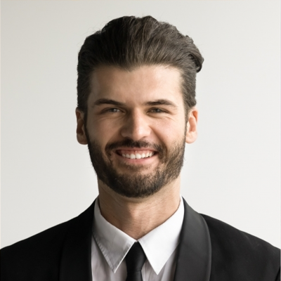
Associate Creative Director, Copy, Brightline & Co, Chicago, IL
2011 - 2014

- Led copy on a national telecom account, partnering with an ACD art director on integrated campaigns.
- Wrote and produced the brand anthem that opened the account's ﬂagship Q4 push.
- Coached a team of ﬁve writers and ran the agency's weekly book club for craft development.

- Helped win three new business pitches as the copy lead in the room.

