DONALD WALKER

Accounts Receivable
Bellevue, WA 12345 | (425) 555-0119 | rebecca.lindqvist@example.com

Professional Experience
Director of Accounts Receivable
Quillwater Health Systems, Bellevue, WA | 2021 - Present

AR leader with 14 years scaling collections, credit, and cash application teams at companies between $80M and $600M in revenue. Built shared-service operations from the ground up and led 3 ERP cutovers. Focus on DSO, bad-debt reserves, and developing team leads who can run the function without daily oversight.

Oracle Cloud ERP HighRadius
JD Edwards
Credit policy design
Bad-debt reserve modeling Shared-services build-out ERP implementation
Team leadership (14 direct/indirect reports)
Audit committee reporting
DSO and working capital strategy
Customer segmentation
Lead a team of 14 across collections, cash application, and credit for a $540M specialty pharmacy.
Brought DSO from 67 days to 44 days over 24 months through a redesigned credit policy and a customer-segmented collection model.
Profile
Reduced bad-debt reserve from 3.1% of revenue to 1.6%, freeing roughly $8.1M back to working capital.
Sponsored the implementation of HighRadius autonomous cash application, taking manual posting from 70% of receipts to under 15%.
Sit on the quarterly credit committee and present aging, reserve, and customer-risk trends to the CFO and audit committee.

AR Manager
Northrise Building Products, Spokane, WA | 2017 - 2021
Key Skills

Managed 8 AR analysts covering distributor, contractor, and retail channels for a
$310M building products company.
Stood up a centralized shared-service center in Spokane, consolidating AR from 4 regional ofﬁces over 9 months.
Negotiated payment plans on roughly $2.4M in distressed contractor balances during the 2020 downturn, recovering 71% in cash.
Owned the AR module conversion from JD Edwards to Oracle Cloud ERP, including UAT and team retraining.
Built career ladders that promoted 3 specialists into team-lead roles.

Senior Credit & Collections Analyst
Vesper Industrial Coatings, Tacoma, WA | 2013 - 2017

Set credit limits and payment terms for the top 50 customers, representing about 60% of company revenue.
Reduced write-offs from $1.3M to $410K annually by introducing credit scoring and quarterly account reviews.
Partnered with legal on accounts referred to outside collections and tracked recovery against agency fees.
Drafted the company's ﬁrst formal credit policy, which was adopted by the board in 2015.


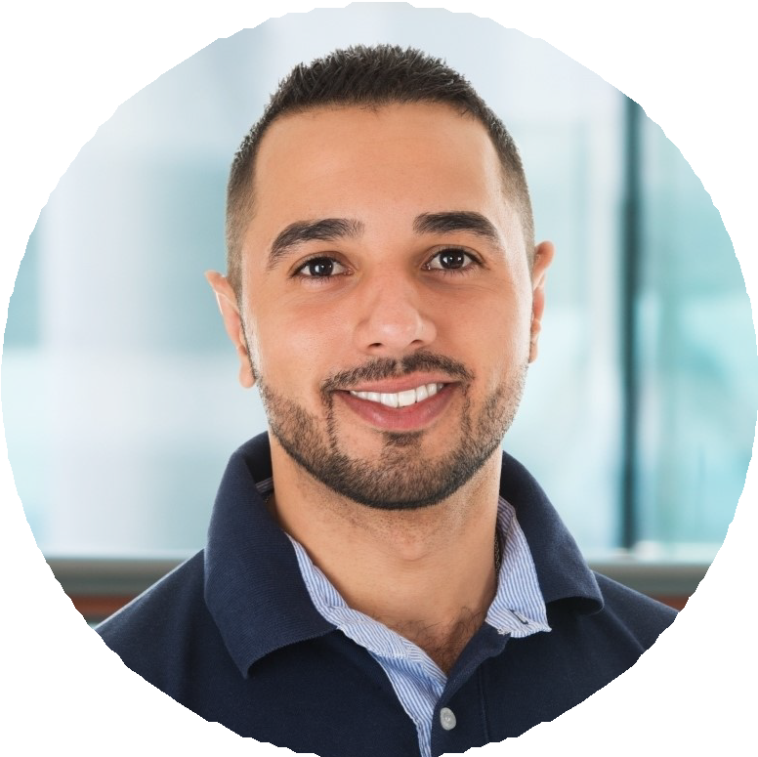
Credit & Collections Analyst
Harborlight Wholesale, Tacoma, WA | 2010 - 2013

Managed collections on a 300-account portfolio across grocery and convenience-store customers.
Pulled D&B reports and recommended credit lines for new account applications.
Reconciled deductions and chargebacks, working closely with brokers and ﬁeld sales.
Reported weekly aging trends to the controller.

Education
M.B.A., University of Washington Foster School of Business, 2016
,

B.S. in Business Administration, Western Washington University, 2009

,

Certiﬁed Credit Executive (CCE), NACM, 2019
,

