DEVON PARK

Tutor

Recent biology graduate and former peer tutor looking for a full-time tutoring role with middle and high school students. Two years of campus tutoring experience in chemistry, biology, and intro statistics. Patient with students who get frustrated, and comfortable explaining the same idea three different ways.

Professional Experience

Contact Information

(608) 555-0173

PEER TUTOR, SCIENCE LEARNING CENTER | GREENFIELD STATE UNIVERSITY, MADISON, WI
2022 – 2024

devon.park@example.com Madison, WI 12345

Key Skills
- General chemistry and biology tutoring
- Intro statistics and algebra
- Small-group and 1:1 instruction
  - Held 12 tutoring hours per week for general chemistry, intro biology, and biostatistics
  - Worked with 60+ unique students across 4 semesters, with 85% reporting a grade improvement of at least one letter
  - Led drop-in exam review sessions of 8-15 students before midterms and finals
  - Wrote short answer-key explanations that the center still uses for common chemistry stumbling blocks

VOLUNTEER HOMEWORK HELPER | LAKESIDE PUBLIC LIBRARY, MADISON, WI 2021 – 2023

- Google Classroom, Canvas
- Zoom and Jamboard
- Patient explanation of step-by-step problem solving
- Bilingual: English and Korean
- Tutored 4-6 elementary students per Saturday in reading and basic math
- Tracked weekly progress in a simple notebook system shared with parents
- Helped translate worksheet directions for two ESL students working in Korean and English
Education

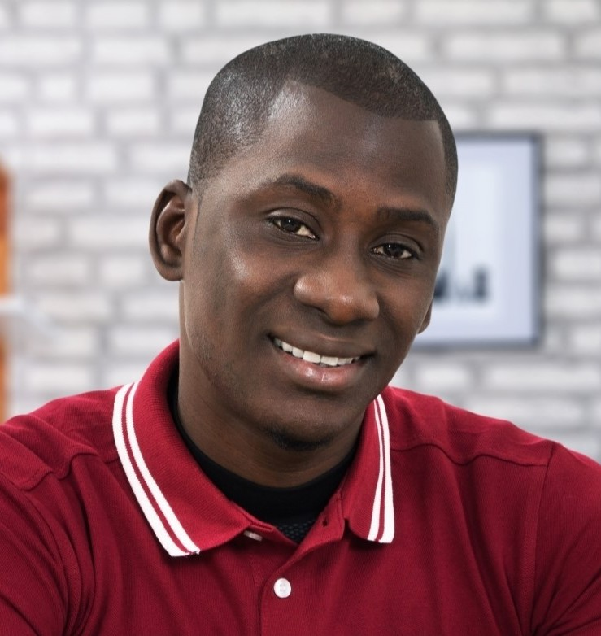



B.S. in Biology, Minor in Education, Greenfield State University, 2024 Wisconsin Substitute Teacher License, 2024

