MAREN HOLLOWAY
CVT
Credentialed veterinary technician with 7 years across general practice and 24-hour emergency care. Comfortable running anesthesia for soft-tissue and orthopedic surgeries, placing central lines, and triaging high-volume ER caseloads. Known by doctors as the tech they want on the hardest cases.
PROFESSIONAL EXPERIENCE

C O N T A C T
I N F O R M A T I O N

(919) 555-0148

maren.holloway@example.com Raleigh, NC

K E Y S K I L L S
2021 - Present
Lead Veterinary Technician | Cardinal Ridge Animal Hospital, Raleigh, NC

Run anesthesia for 12 to 18 surgical patients per week including TPLOs, splenectomies, and dental extractions; zero anesthetic mortalities across 740+ procedures
Built a new patient triage workﬂow with the medical director that cut average ER wait time from 38 minutes to under 15
Train and mentor 6 assistants and 2 new CVTs, owning skills sign-offs for IV catheters, blood draws, and radiograph positioning
Manage controlled drug logs and DEA biennial inventory; passed two unannounced state board inspections with no ﬁndings
Lead daily rounds with the doctor team and own treatment sheet handoff between day and overnight shifts

Anesthesia monitoring (ISO/sevo, multiparameter)
IV catheter placement (cephalic, saphenous, jugular)
Dental prophy and digital dental radiographs
ER triage and CPR (RECOVER certiﬁed)
Cornerstone and ezyVet practice management
Controlled substance logging and DEA compliance
Blood gas, lactate, PCV/TS interpretation
Client communication and discharge education
Staff training and skills sign-offs
2018 - 2021
Veterinary Technician (Emergency & Critical Care) | BluePine Veterinary Specialists, Durham, NC

Triaged roughly 40 to 60 ER patients per shift; ﬁrst tech on blocked cats, GDVs, HBC trauma, and toxin ingestions
Placed jugular and saphenous catheters, ran CRIs (fentanyl, lidocaine, ketamine), and monitored ventilator patients overnight
Trained junior staff on lactate, blood gas, and PCV/TS interpretation during morning rounds
Worked closely with criticalists to draft anesthesia plans for high-risk patients with cardiac and renal disease

2016 - 2018
Veterinary Assistant | Highgrove Pet Clinic, Cary, NC

Restrained for exams, vaccines, and venipuncture across an average of 28 appointments per day
Ran in-house IDEXX bloodwork, fecals, and ear cytologies; ﬂagged abnormal results for the attending DVM
Cleaned and packed surgical instruments and ran the autoclave for daily dental and spay/neuter blocks




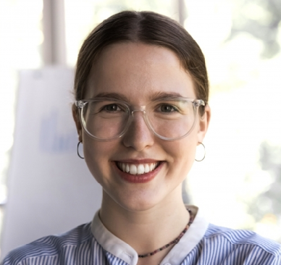
EDUCATION
AAS, Veterinary Technology, Central Carolina Community College, 2018 Credentialed Veterinary Technician (CVT), North Carolina, License #VT-08421

