ANDREW YOUNG

Electrical Engineer
Portland, OR 12345 | (503) 555-0166 | yuki.brennan@example.com

Professional Experience
Lead Electrical Engineer, Renewables
Cascadia Grid Partners, Portland, OR | 2020 - Present

Lead electrical engineer with 17 years across utility-scale renewables, BESS integration, and substation design. PE in ﬁve states. Runs design teams of 8 to 14, owns interconnection schedules, and has stamped over
$180M in project work.

Substation design (transmission and distribution)
BESS and inverter-based resource integration
ASPEN OneLiner, CDEGS, PSS/E
ETAP, SKM, EasyPower
SEL relay settings and coordination
Utility interconnection (BPA, PaciﬁCorp, BPA TPL)
SCADA and protection scheme design
IEEE 1547, NERC PRC standards
Team leadership (8 to 14 engineers)
Project budgeting and resource planning
Lead electrical engineer on a 220 MW solar plus 80 MWh storage project from preliminary design through COD; energized 6 weeks ahead of contractual milestone.
Manage a team of 12 EEs and designers across two ofﬁces; built the load-ﬂow review process that knocked late-stage drawing revisions down by roughly half.
Profile
Own utility interconnection coordination with BPA and PaciﬁCorp, including SCADA points lists and protection settings.
Set internal standards for 34.5 kV collection system design now used on every Cascadia project.
Sit on the technical review board for go/no-go decisions on projects above $25M.
Key Skills

Principal Electrical Engineer
Ironwood Substation Engineering, Boise, ID | 2016 - 2020

Stamped substation physical and protection designs for 115 kV and 230 kV projects across the Mountain West.
Led the SEL relay settings practice; standardized templates cut settings-calc time per breaker by about a third.
Mentored ﬁve engineers to PE licensure during tenure.
Served as client-facing lead on three utility frame agreements totaling $48M. Reviewed and red-lined all relay coordination studies leaving the ofﬁce.
Senior Electrical Engineer
Ironwood Substation Engineering, Boise, ID | 2013 - 2016

Designed AC and DC station service, control buildings, and grounding for 7 substation projects.
Performed ground grid analysis in CDEGS and protection coordination in ASPEN OneLiner.
Acted as engineer of record on smaller distribution substations after licensure. Trained the ofﬁce on a new ASPEN workﬂow that became ﬁrm standard.


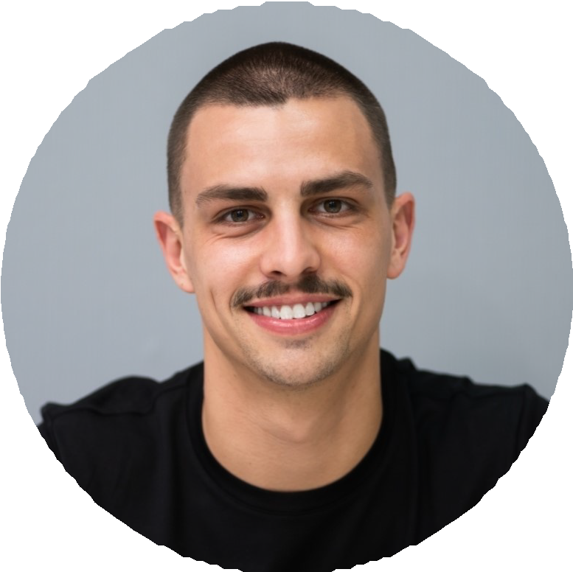
Electrical Engineer
Highline Power Consultants, Salt Lake City, UT | 2010 - 2013

Designed distribution feeder relocations and reconductoring packages for two municipal utilities.
Built fault studies and arc-ﬂash labels for a regional cooperative covering 1,400 miles of line.
Walked feeder routes with the operations crew to validate ﬁeld conditions against drawings.
Passed PE exam during second year on the job.

Electrical Engineer in Training
Highline Power Consultants, Salt Lake City, UT | 2008 - 2010

Drafted one-lines, schematics, and conduit schedules under PE supervision. Supported relay testing ﬁeld trips and logged test results.
Built the ﬁrm's ﬁrst internal NEC training series for new hires. Completed manufacturer training on SEL-351 and SEL-487 relays.

Education
M.S. Electrical Engineering, Power Systems, University of Utah, 2010
,

B.S. Electrical Engineering, Oregon State University, 2008
,

Professional Engineer (PE), Electrical, OR, WA, ID, UT, MT
,

IEEE Senior Member
,

