MAYA ELLINGTON
Copywriter

A B O U T M E

C O N TA C T
I N F O R M AT I O N

(503) 412-8867

maya.ellington@example.co m

Portland, OR 12345

E D U C AT I O N

B.A., English (Creative Writing concentration), University of Oregon, 2018
Miami Ad School portfolio bootcamp, 2019
Senior copywriter with 7 years writing for DTC brands, B2B SaaS, and lifestyle retail. Lead end-to-end campaign work from concept through launch, partnering with art directors, brand strategists, and paid media teams. Comfortable shifting voice across email, landing pages, OOH, and short-form video scripts.
P R O F E S S I O N A L E X P E R I E N C E
SENIOR COPYWRITER | NORTHGROVE & VALE, PORTLAND, OR
2021 - PRESENT

Lead copy on the brand's spring and fall product drops, writing site, email, and paid social in tandem with the creative director.
Rewrote the homepage and PDP narrative for the loungewear category, lifting add-to-cart rate by 28% in the eight weeks after launch.
Built a tone-of-voice guide adopted across CX, retention, and inﬂuencer teams, cutting back-and-forth review cycles by roughly half.
Concept partner on a four-spot YouTube pre-roll campaign that pulled the brand's ﬁrst 2M+ view tally on a single asset.
Mentor two junior copywriters through weekly crits and shared briefs.

K E Y S K I L L S
Brand voice development Long-form and short-form copy Concepting with art directors Email and lifecycle writing Landing page and SEO copy Video scripts and VO
Figma, Notion, Asana Client presentation A/B test copy
COPYWRITER | HELLWOOD CREATIVE (AGENCY), PORTLAND, OR
2019 - 2021

Wrote integrated campaigns for a regional credit union, a meal-kit startup, and a wellness app, presenting concepts directly to clients.
Shipped 40+ landing pages tied to paid social funnels, with the top three driving a blended CPA below $14.
Pitched the tagline that anchored a statewide tourism push picked up by AdWeek's weekly roundup.
Sat in on user research sessions to pull verbatims into ad copy and onboarding ﬂows.

JUNIOR COPYWRITER | SUNDIAL MEDIA GROUP, EUGENE, OR
2018 - 2019

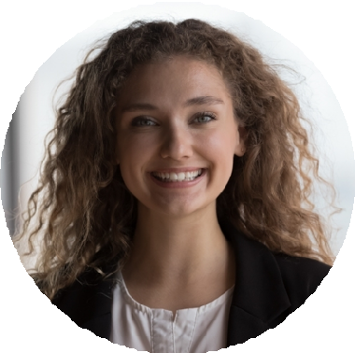



Drafted blog posts, product descriptions, and lifecycle emails for a roster of 12 small-business clients.
Took over a stalled e-commerce client and rebuilt their welcome series, taking open rates from the high teens into the mid-30s.
Sourced and edited UGC captions for Instagram and Pinterest content calendars.

