MARISOL VEGA

School Counselor

School counselor with seven years supporting middle and high school students across academic planning, college advising, and social-emotional support. Manages a 320-student caseload while co-leading MTSS and accommodation planning with teachers and families.
Bilingual in Spanish and English.

Professional Experience

Contact Information

(401) 555-0182

SCHOOL COUNSELOR (GRADES 9-12) | BLACKSTONE RIDGE HIGH SCHOOL, PROVIDENCE, RI
2020 – PRESENT

marisol.vega@example.com Providence, RI 12345

Key Skills
- Manage a caseload of 318 students across all four grades, covering course selection, transcript review, credit recovery, and post-secondary planning.
- Rebuilt the junior-year college process into a five-meeting sequence; FAFSA completion on the senior class rose from 61% to 84% in two years.
- Co-chair the MTSS team with the assistant principal; screen tier-2 referrals weekly and match students to check-in/check-out, small groups, or outside
referrals.

  - MTSS and tier-2 intervention planning
  - 504 plan writing and case management
  - College and career planning platforms
  - PowerSchool and Infinite Campus
    - Write and coordinate 40+ 504 plans a year, running the intake meeting with parents and translating for Spanish-speaking families in-house.
    - Run a lunchtime grief group after a student death in 2022; partnered with a community clinician and family services for eight weeks of sessions.

SCHOOL COUNSELOR (GRADES 6-8) | CEDAR POINT MIDDLE SCHOOL, WARWICK, RI
2017 – 2020

  - Crisis response and risk assessment
  - Small group counseling (grief, anxiety, social skills)
  - College and financial aid advising (FAFSA and
institutional aid forms)
  - Bilingual: Spanish (native) and English
  - ASCA National Model alignment
  - Delivered the SEL curriculum in all 6th-grade advisory blocks, roughly 22 lessons a year across nine sections.
  - Chaired the attendance intervention team; chronic absence in the 7th grade cohort dropped from 24% to 17% across one school year.
  - Screened and referred students for outside mental health services, maintaining a working list of 15+ area providers who took RIte Care.
  - Ran 8th-grade high school transition nights in English and Spanish for around 140 families each spring.

Education

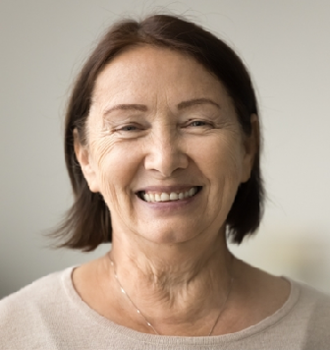


M.Ed. School Counseling, Rhode Island College, 2017

B.A. Psychology, University of Rhode Island, 2015 State School Counselor License, in good standing

