ELENA
OSTROWSKI
Technologist

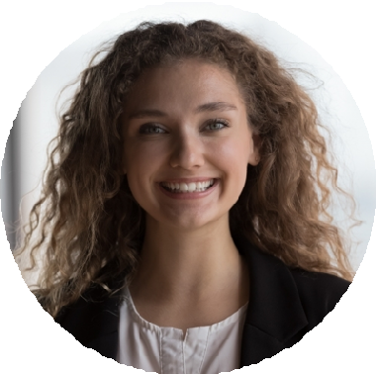



C O N TA C T
I N F O R M AT I O N

(616) 555-0164

elena.ostrowski@example.co m

Grand Rapids, MI 12345

E D U C AT I O N
B.S. Medical Laboratory Science, Michigan State University, 2018
Board of Certiﬁcation, Medical Laboratory Scientist, 2018, current
Specialist in Blood Bank exam eligible, planned 2025

K E Y S K I L L S
Immucor Echo Lumena blood bank
Gel card and tube method serology
Antibody identiﬁcation panels
Massive Transfusion Protocol support
Coagulation analyzer platforms Sysmex XN-series hematology Roche cobas chemistry SoftBank and Epic Beaker LIS
Blood bank and accreditation inspection prep
Competency assessment and sign-off

A B O U T M E
Board-certiﬁed Medical Laboratory Scientist with six years of generalist bench experience, strongest in blood bank and coagulation. Have worked both a Level II trauma center and a 24-hour reference lab, and I am the person the evening crew calls for antibody workups.

P R O F E S S I O N A L E X P E R I E N C E
CLINICAL LABORATORY SCIENTIST, BLOOD BANK | NORTHSHORE LAKES HEALTH SYSTEM, GRAND RAPIDS, MI
2020 - PRESENT

Primary blood bank tech on day shift for a Level II trauma center; handle type and screens, antibody identiﬁcation panels, and massive transfusion activations.
Resolved a warm autoantibody workup during an oncology admission that had stalled two prior shifts, releasing least-incompatible units within 90 minutes of the call.
Maintain competency records for eight rotating generalists on the blood bank bench and sign off annual competencies.
Represent the lab in monthly transfusion committee meetings; presented a review of 47 emergency release events over one year to support a policy revision.
Validated a new gel card lot and updated the standard operating procedure; validation packet passed blood bank assessor review on ﬁrst submission.

MEDICAL TECHNOLOGIST, GENERALIST | FAIRHAVEN REFERENCE LABORATORY, KALAMAZOO, MI
2018 - 2020

Rotated across chemistry, hematology, and coag in a 24-hour reference lab serving 40+ clinics.
Worked up abnormal coags, including mixing studies and factor assays, and communicated results to ordering providers.
Kept the second-shift Sysmex line running through a three-week reagent backorder by coordinating lot substitutions with the vendor.
Trained as backup for microbiology gram stain reads and rapid antigen testing during ﬂu and respiratory virus surges.

