Joseph Anderson
Accounting Clerk

Senior accounting clerk with 6 years handling payables, receivables, and month-end close for mid-sized distributors and nonproﬁts. Owns full-cycle vendor payments, three-way match, and bank reconciliations across multiple entities.
Known for cleaning up messy vendor ﬁles and closing the books two days earlier than the prior team.

CONTACT INFORMATION
PROFESSIONAL EXPERIENCE
Senior Accounting Clerk | Blackwater Marine Supply, Providence, RI
2021 - Present

(401) 555-0182
d.ortegareyes@exampl e.com
Providence, RI 12345

KEY SKILLS
- Process 400-600 vendor invoices per month across three legal entities in Sage Intacct; keep three-way match exception rate under 3%.
- Rebuilt the vendor master ﬁle, merged 214 duplicate records and ﬂagged 11 inactive vendors still receiving electronic payments.
- Reconcile four operating bank accounts and two lockboxes weekly; catch coding errors before they hit the trial balance.
- Cut month-end payables close from six business days to four by pre-accruing recurring freight and utility invoices.

  - Sage Intacct
  - QuickBooks Enterprise
  - Trained two junior clerks on 1099 workﬂow and W-9 collection; ﬁled 187 forms with zero tax agency notices last cycle.

  - NetSuite (basic)
  - Excel (XLOOKUP, pivot tables, conditional sum formulas)
  - Three-way match and purchase order reconciliation
  - 1099 vendor tax form ﬁling
  - Bank and lockbox reconciliation
  - Electronic payments and positive pay
Accounting Clerk | Narragansett Community Health Alliance, Warwick, RI
2018 - 2021
    - Handled AR posting and cash application for grant reimbursements and patient billing, roughly $2.3M per quarter.
    - Reconciled donor-restricted fund accounts monthly and ﬂagged variances to the staff accountant.
    - Prepared bi-weekly deposit reports and coded credit card receipts in QuickBooks Enterprise.
    - Assisted the auditors during annual A-133 ﬁeldwork by pulling invoice samples and payroll allocations on request.

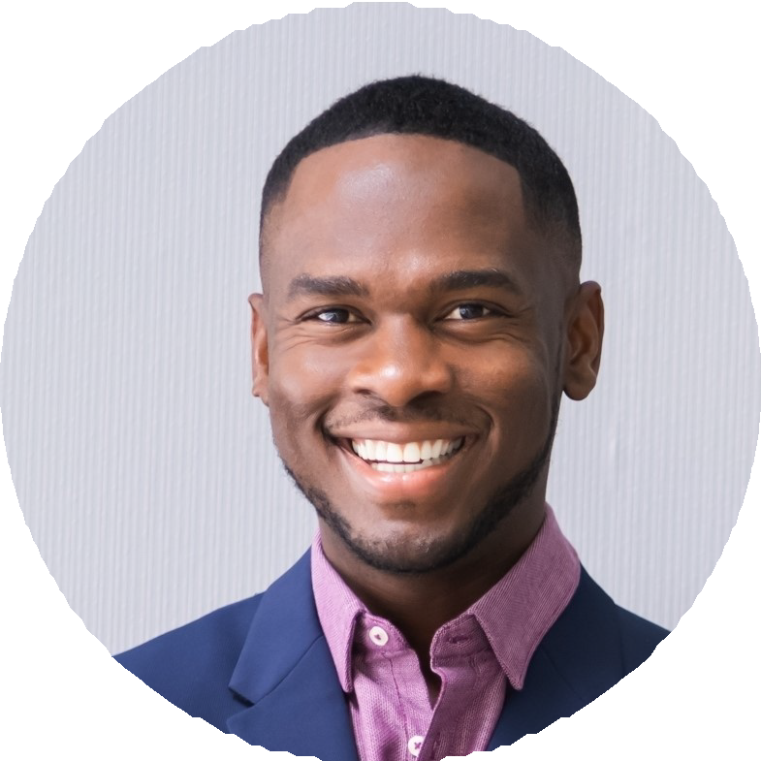



  - Journal entries and accruals
  - Vendor master data cleanup

EDUCATION
Associate of Science in Accounting, Community College of Rhode Island, 2018
Certiﬁed Bookkeeper (CB), American Institute of Professional Bookkeepers, 2022

