ELENA VASQUEZ-

ORTIZ
M . S . , C C C - S L P

CONTACT INFORMATION

(520) 555-0173

elena.vasquez.slp@example.co m
CCC-SLP with 4 years in outpatient pediatric and early intervention settings. Bilingual (Spanish/English) evaluator with a focus on late talkers, phonological disorders, and family-centered coaching in the home.

PROFESSIONAL EXPERIENCE

Speech-Language Pathologist | Saguaro Kids Therapy, Tucson, AZ | 2022 – Present

Tucson, AZ 12345

KEY SKILLS
Bilingual evaluation (Spanish/English)
Standardized preschool language, articulation, and early receptive-expressive assessments
Hanen It Takes Two to Talk (certiﬁed)
Phonological process therapy (cycles approach)
Arizona early intervention family service plan writing
Parent coaching, telepractice
EMR: Central Reach, Fusion Web Clinic
Evaluate and treat 35-40 children weekly ages 18 months to 12 years, with roughly 40 percent of the caseload receiving services in Spanish.
Completed 54 initial evaluations in 2024 using standardized preschool language, articulation, and early receptive-expressive measures in Spanish and English editions.
Built a phonological-processes group for 4-5 year olds; average client discharged from the cycle after 22 weeks meeting age-expected patterns.
Coach parents through weekly 10-minute home practice plans and track carryover on the client portal.
Consult with local Head Start classrooms twice a month on speech-sound screening referrals.

Early Intervention SLP (Contract) | Desert Sky Early Intervention Services, Tucson, AZ | 2020 – 2022

Delivered in-home early intervention services to 22 families across Pima County, writing family service plan outcomes with the primary service provider model.
Trained caregivers on Hanen-style responsive language strategies during natural routines (bath, mealtime, book sharing).
Documented visits in Central Reach with same-day upload to meet contract requirements.

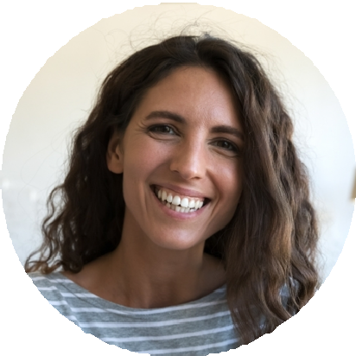



EDUCATION

M.S., Speech-Language Pathology, University of Arizona, 2020

B.S., Speech, Language, and Hearing Sciences, Arizona State University, 2018

State Speech-Language Pathology License, active; Certiﬁcate of Clinical Competence in Speech-Language Pathology since 2021

