
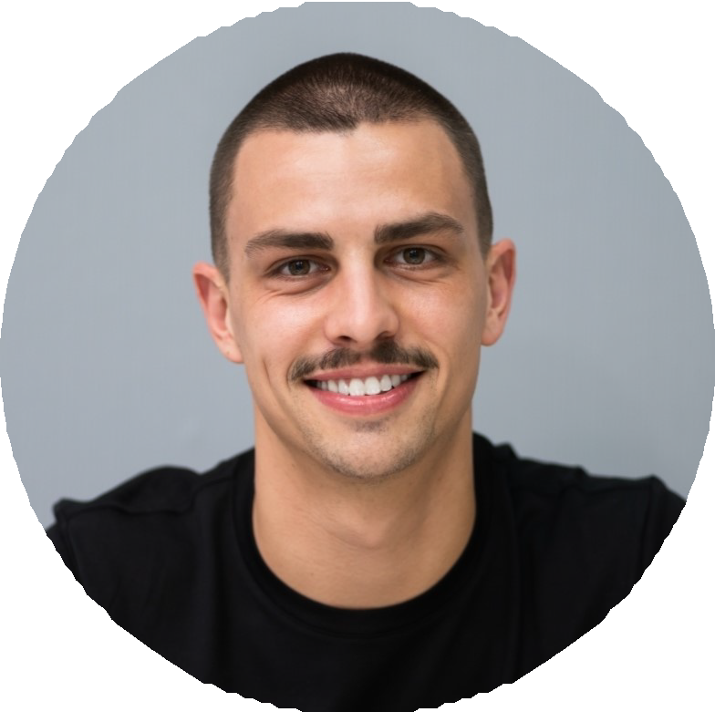
PRIYA
RANGANATHAN
Resident Assistant

Contact Information

 (812) 555-0102

p.ranganathan@example.c om
 Bloomington, IN 12345

Education

M.Ed. in Higher Education and Student Affairs, Great Lakes State University, 2020

B.A. in Sociology, Great Lakes State University, 2018

Key Skills
Live-in Resident Director with six years in campus housing, currently responsible for a 612-bed ﬁrst-year complex and a professional and student staff of 18. Background in crisis on-call rotations, Title IX and student-of-concern case management, budget oversight above $85K, and resident assistant training curriculum design.

Professional Experience

Resident Director | Jul 2022 - Present
Willow Creek Complex, Wabash Central University, Bloomington, IN

Oversee a 612-bed ﬁrst-year housing complex with 14 RAs, one graduate assistant, and three professional staff.
Manage a $87,500 annual operating and programming budget; closed FY24 at 98% of budget with no line-item overruns.
Serve in the campus on-call Resident Director rotation (one week every six weeks); handled 47 elevated incidents last year including transports, welfare checks, and bias-related reports.
Rewrote the fall resident assistant training curriculum in 2023 with the Assistant Director; post-training assessments showed a 22-point jump in average conﬁdence on mandatory reporting scenarios.
Chair the Housing conduct panel for the complex; adjudicated 68 low-and mid-level cases during the 2023-24 academic year with written outcomes issued within ﬁve business days.

Live-in Resident Director on-call and crisis response
Resident assistant training curriculum design
Student conduct adjudication
Student-of-concern and behavioral intervention case management
Title IX responsible employee
Budget oversight ($85K+)
Staff supervision (undergrad and grad)
Search committees and hiring
StarRez, Maxient, Advocate
Mental Health First Aid, suicide prevention gatekeeper training
Assessment and post-training surveys
Housing opening and closing operations
Assistant Resident Director | Jul 2020 - Jun 2022
North Quad Community, Wabash Central University, Bloomington, IN

Supervised 9 RAs across a 310-bed sophomore community; conducted biweekly one-on-ones and end-of-semester evaluations.
Co-led the Residence Life diversity and inclusion committee; launched a monthly identity-based dialogue series that ran 14 sessions over two years.
Coordinated opening and closing for the community across four semesters; move-in day feedback surveys averaged 4.5 out of 5 from families.
Managed follow-up for 31 students of concern; documented in Maxient and coordinated referrals with campus counseling and the Dean of Students.
Served on the search committee that hired three RDs and one graduate coordinator.

Graduate Hall Coordinator | Aug 2018 - May 2020
Sycamore Hall, Great Lakes State University, East Lansing, MI

Supervised 7 undergraduate RAs in a 180-bed traditional-style hall while completing M.Ed. in Higher Education.
Ran weekly staff meetings and one-on-ones; coordinated with facilities on 240+ work orders across two years.
Facilitated in-service training on bystander intervention, inclusion for queer and trans residents, and roommate mediation.

- Managed a $12,000 programming and community-development budget across the resident assistant staff.
Senior Resident Assistant | Aug 2017 - May 2018
Redwood Hall, Great Lakes State University, East Lansing, MI

- Lead resident assistant for a staff of six on a 200-bed ﬂoor plan; assisted the Resident Director with duty scheduling and program approvals.
- Ran August training modules on documentation and de-escalation for the incoming resident assistant class.
- Handled ﬁrst-response on 18 documented incidents during senior year.
- Mentored two RAs who were later selected as Senior RAs the following year.

