JOSEPH ANDERSON

Psychology
Minneapolis, MN 12345 | (612) 555-0176 | d.ashworth@example.com

Professional Experience
Clinical Psychologist, Neuropsychology Service
Northgate Memorial Hospital, Minneapolis, MN | 2019 - Present

Clinical psychologist with a decade of practice split between hospital-based neuropsychology and private outpatient work. Specialty in adult attention and mild cognitive concerns evaluations, plus short-term therapy for executive functioning. Comfortable running a testing practice and reporting to referring neurologists and psychiatrists.
Complete 6 to 8 adult neuropsychological evaluations per week, most referred by neurology for suspected cognitive decline, head injury sequelae, or adult attention concerns.
Reduced report turnaround time from 22 business days to 11 by templating narrative sections and using a scoring software pipeline.
Profile
Present ﬁndings in weekly interdisciplinary case conference with neurology, psychiatry, and speech-language pathology.
Supervise one postdoctoral fellow per year through report drafting and feedback sessions.
Serve on the hospital's cognitive screening protocol committee for the memory clinic.
Staff Psychologist
Lakeview Behavioral Associates, St. Paul, MN | 2016 - 2019
Key Skills


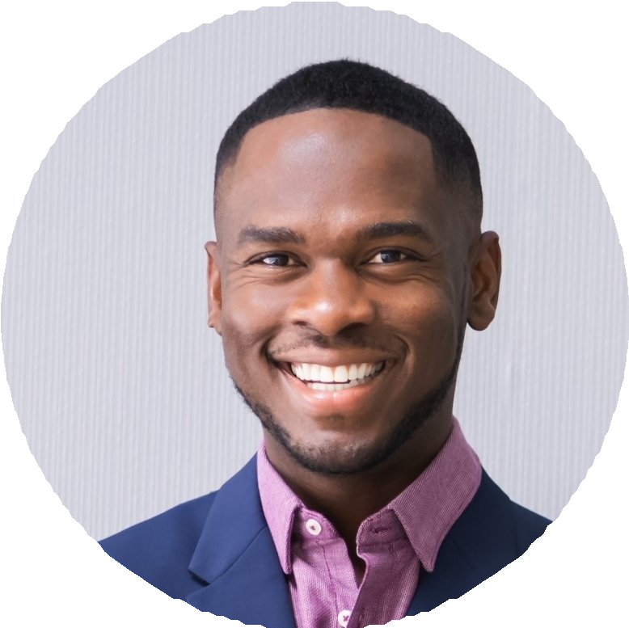
Adult neuropsychological assessment across intelligence, memory, and executive functioning
Adult attention concerns evaluation and differential diagnosis
Mild cognitive impairment and early dementia workup
Short-term cognitive behavioral therapy for executive functioning
Integrated report writing for neurology and psychiatry referrals
Interdisciplinary case consultation and feedback sessions
Supervision of postdoctoral fellows and practicum trainees
Clinical interviewing and collateral history gathering
Electronic health record and digital test scoring platforms
Conﬁdential documentation and record management
PSYPACT-informed telehealth assessment practices
Caregiver education and psychoeducation for cognitive decline
Carried a mixed caseload of therapy and assessment, averaging 24 client-facing hours per week.
Built a brief therapy protocol for adult attention concerns that became a standing offering across the group's four clinicians.
Trained front-desk staff on managing crisis calls and warm handoffs to on-call clinicians.
Represented the practice at referral events with local primary care groups.

Postdoctoral Fellow, Neuropsychology
Twin Cities VA Medical Center, Minneapolis, MN | 2014 - 2016

Completed 90+ comprehensive neuropsychological batteries with veterans referred for cognitive concerns.
Drafted integrated reports incorporating medical history, imaging, and behavioral observations.
Co-led a caregiver education group for families of veterans with early-stage dementia.

Education
Ph.D. in Clinical Psychology, Neuropsychology Track, University of Iowa, 2014
,

B.A. in Psychology, Minor in Neuroscience, Carleton College, 2008
,

State Psychologist License, Minnesota (active since 2016)
,

APA-Accredited Predoctoral Internship, Hennepin County Medical Center, 2013-2014
,

