LAURA KING
Accounting Clerk

ABOUT ME

CONTACT INFORMATION

 (208) 555-0119

priya.ramaswamy@example. com
 Boise, ID 12345

KEY SKILLS
- Sage 300 construction edition
- NetSuite
- QuickBooks Online
- Excel (conditional sum formulas, lookup formulas, pivots)
- Bank and credit card reconciliation
- Prepaid and accrual schedules
- Fixed-asset subledger
- Job costing and certiﬁed payroll intake
- Deferred revenue schedules
- Cash application
- 1099 ﬁling
- Junior clerk training
Eight years across payables, receivables, and month-end close for construction and software employers. Owns bank recs, prepaid schedules, and fixed-asset subledger entries. Known for finding coding errors before the close and mentoring junior clerks on accounting system workflows.

PROFESSIONAL EXPERIENCE
Senior Accounting Clerk
Foothill Peak Construction, Boise, ID | 2020 - Present
  - Own weekly payables run in Sage 300 for two entities; process $1.8M in subcontractor and material payments per month.
  - Maintain lien waiver tracking and hold payments until conditional waivers are received; reduced waiver-related payment delays by roughly a third.
  - Reconcile eight bank and credit card accounts monthly and prepare the prepaid insurance and equipment lease schedules for the controller.
  - Post recurring depreciation and amortization journal entries; keep the ﬁxed-asset subledger tied to the general ledger within $50.
  - Trained three new payables clerks over two years on Sage 300, job costing codes, and certiﬁed payroll intake.
Accounting Clerk
Cascade Peak Software, Meridian, ID | 2017 - 2020
  - Applied customer cash receipts against SaaS invoices in NetSuite; kept unapplied cash under $8,400 at any given month-end.
  - Handled deferred revenue schedules for annual contracts and prepared the roll-forward for the staff accountant.
  - Sent receivables aging follow-ups on invoices past 45 days and worked with customer service on billing disputes.
  - Assisted with the transition from QuickBooks Online to NetSuite, including vendor and customer master imports.

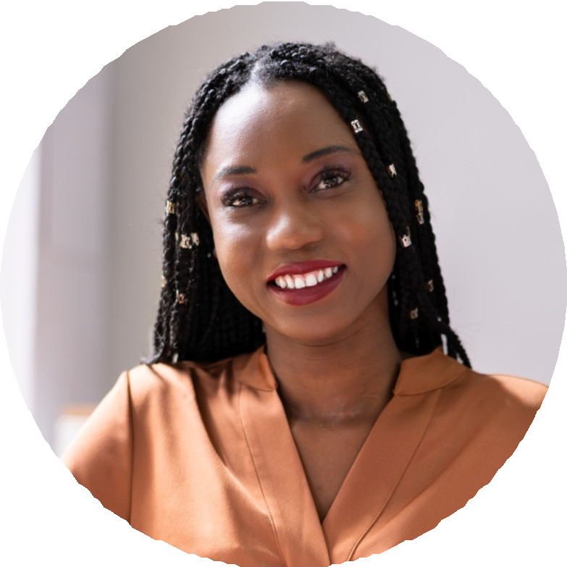
EDUCATION
Bachelor of Science in Accounting, Boise State University, 2017
Certiﬁed Bookkeeper (CB), American Institute of Professional Bookkeepers, 2020

