DEVON PRIESTLY

X Ray Technician

Newly registered radiographer with clinical rotations across three hospital systems and a community imaging center. Comfortable on general radiography, portables, and surgical fluoroscopy under supervision. Steady with anxious patients and careful about radiation dose on every exam.

Contact information

(616) 555-0178

devon.priestly@example.co m

Grand Rapids, MI 12345

Key skills

General radiography and portable exams
Fluoroscopy assist (barium and C-arm)
Pediatric and geriatric positioning
Contrast prep and patient screening
Image archiving (Merge) and radiology information entry
Epic Radiant order workflow
Dose minimization and pregnancy screening
Room turnover and infection control

Professional Experience
STAFF RADIOLOGIC TECHNOLOGIST | KENTWOOD COMMUNITY HOSPITAL, GRAND RAPIDS, MI
2023 - PRESENT

Perform 30 to 38 general radiography exams per shift across emergency, inpatient portables, and outpatient add-ons.
Rotate weekend OR call, assisting orthopedic surgeons with C-arm imaging for hip and ankle fixation cases.
Keep personal repeat rate at 5.1% per quarterly QA audit, below the 8% department benchmark.
Stock and rotate contrast, lead aprons, and portable batteries at start of every shift.

RADIOLOGIC TECHNOLOGY STUDENT INTERN | GRAND RIVER IMAGING PARTNERS, WYOMING, MI
2022 - 2023

Completed 1,850 clinical hours across three hospital sites, meeting all program competency requirements before graduation.
Assisted staff techs with fluoroscopic barium studies, patient prep, and post-exam cleanup.
Practiced positioning for over 400 documented exams under direct supervision.

Education
A.A.S. Radiography, Grand Rapids Community College, 2023 Registered radiographer, 2023

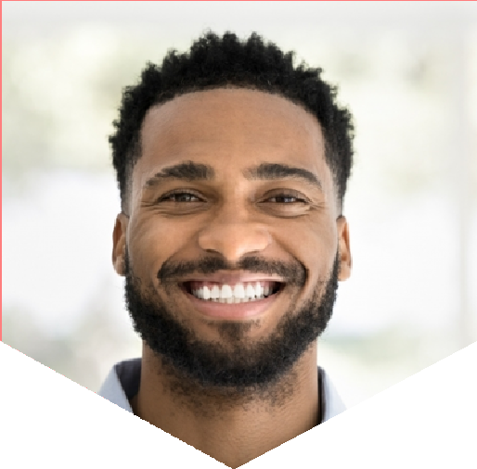

State radiographer certification, current

BLS for Healthcare Providers, current

