PRIYA
CHANDRASEKARAN
M.S., CCC-SLP
Speech-language pathologist certiﬁed by ASHA with 6 years across pediatric outpatient, school, and acute inpatient settings. Bilingual English/Tamil clinician known for communication device evaluations, swallowing management, and coaching parents through home practice plans.

CONTACT INFORMATION
(919) 555-0142
priya.chandra.slp@exa mple.com

PROFESSIONAL EXPERIENCE
Speech-Language Pathologist | Wake Pediatric Therapy Group, Raleigh, NC
2021 - Present

Raleigh, NC 12345

KEY SKILLS
- Manage a caseload of 42 pediatric clients weekly with diagnoses spanning apraxia of
speech, autism, language delay, and ﬂuency disorders.
- Completed 68 communication device evaluations in 2023, matching 9 children to dedicated speech-generating devices and training families on device programming.
- Co-treat with occupational therapy on a monthly sensory-feeding group; caregiver-reported mealtime distress dropped noticeably across the 12-week cycle.

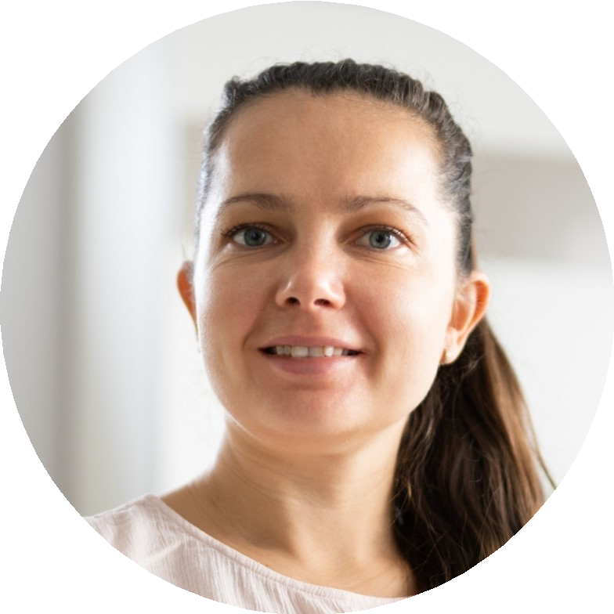



  - Communication device
evaluation and programming across major speech-generating platforms
  - Pediatric dysphagia and feeding
  - Instrumental swallow study interpretation and texture-modiﬁed diet leveling
  - Trained in tactile-cueing motor speech treatment
  - IEP writing and Medicaid documentation
  - Bilingual service delivery (English/Tamil)
  - Picture-exchange communication and Hanen It Takes Two to Talk
  - EMR: WebPT, Epic, SimplePractice
    - Wrote and defended IEP goals for school-district contracts, keeping documentation compliant with NC Medicaid billing requirements.
    - Precept graduate externs from two in-state university programs each semester, averaging 2 students per year.
Speech-Language Pathologist (per diem) | Cedar Ridge Regional Hospital, Durham, NC
2019 - 2021
    - Rotated through acute care, critical care, and inpatient rehab covering roughly 8-10 evaluations per shift.
    - Performed bedside swallow evaluations and instrumental swallow studies under radiology, recommending standardized texture-modiﬁed diets.
    - Trained nursing staff on aspiration precautions during a unit-wide dysphagia education push.

EDUCATION
M.S., Speech-Language Pathology, East Carolina University, 2019 B.A., Communication Sciences and Disorders, in-state university, 2017
State Speech-Language Pathology License, active; Certiﬁcate of Clinical Competence in Speech-Language Pathology

