Carol Lee
Audio Engineer

Assistant engineer with two years of studio experience supporting tracking and mix sessions for hip-hop, R&B, and indie clients. Fast at session setup, patching, and headphone cues, and comfortable staying quiet in the room until a lead engineer needs something.


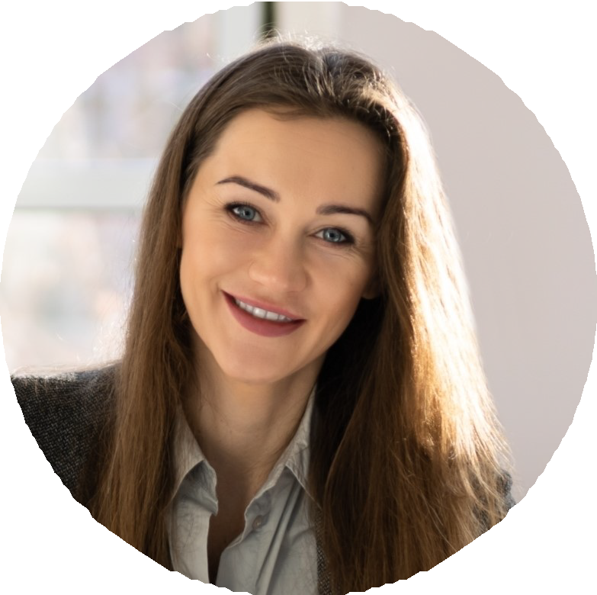




Contact Information

(512) 555-0192
priya.rama@example.com Austin, TX 12345

Education

B.A. Sound Recording Technology, University of North Texas, 2022

Pro Tools training coursework, Music, 2023

Key Skills

Pro Tools session setup and templates
Mic selection and placement Patchbay routing and signal ﬂow
Headphone cue systems (Hear Back, Aviom)
Drum tuning and prep
Outboard patching (1176, LA-2A, and comparable mic preamps)
Session comping and playlist management
Studio maintenance and cable repair
Client hospitality and session logistics

Professional Experience

Assistant Engineer | 2023 - Present
Cottonmouth Studios, Austin, TX

Set up an average of 4 to 6 sessions per week across two rooms, including mic selection from the studio locker, patching, and building headphone mixes for up to 8 musicians.
Ran Pro Tools during tracking dates for artists on Dualtone and Merge, capturing takes, marking comp choices, and prepping sessions for out-of-town mix engineers.
Cut daily session breakdown time from about 40 minutes to 22 by rebuilding the studio's template and label system.
Maintain mic cabinet, cables, and the outboard rack, logging repairs and ﬂagging tube swaps for the chief engineer.

Studio Intern | 2022 - 2023
Backline Rehearsal & Recording, San Marcos, TX

Shadowed lead engineer on tracking sessions two to three days a week, learning session ﬂow and console signal path.
Handled load-in for touring artists using the live room for pre-production, including drum tuning and amp placement.
Digitized about 60 hours of legacy digital tape material to Pro Tools for a local archive project.

