DEVON
MARCHETTI

Office Coordinator

Office coordinator with two years of front-desk and administrative experience in a 45-person marketing agency. Known for keeping supply closets stocked, calendars unbroken, and visitors greeted before they have to ask.

Contact information

(208) 555-0187

devon.marchetti@example.com Boise, ID 12345

Education
A.A. BUSINESS ADMINISTRATION, COLLEGE OF WESTERN IDAHO, 2022

Key skills
Professional experience
OFFICE COORDINATOR | NORTHLARK CREATIVE, BOISE, ID | 2023 - PRESENT

Greet clients and vendors at the front desk, manage inbound calls, and route deliveries for a 45-person creative agency.
Order ofﬁce and kitchen supplies on a rolling par sheet; caught a duplicate coffee-service invoice that recovered $1,320 in credits from the vendor.
Book conference rooms and coordinate client lunches, including dietary tracking for pitch meetings of up to 20 people.
Support onboarding by setting up desks, ordering swag, and walking new hires through building access on day one.

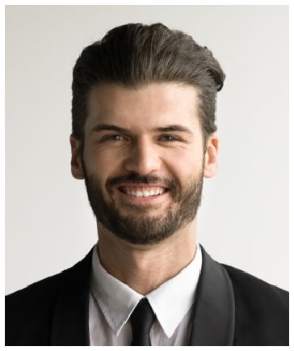



Front desk and visitor greeting
Google Workspace and Microsoft 365
Calendar and conference room scheduling
Supply ordering and inventory Slack, Zoom, DocuSign
Mail and shipping coordination New-hire desk setup
Basic expense reports

RECEPTIONIST AND OFFICE ASSISTANT | CABOT & PINE FAMILY DENTISTRY, MERIDIAN, ID | 2022 - 2023

Checked in 40 to 60 patients per day, veriﬁed insurance, and collected copays.
Managed the six-provider schedule and ﬁlled same-day cancellations from a standby list to keep chair-time utilization above target.
Kept front-ofﬁce supplies and patient forms stocked; handled inbound calls, faxes, and scanned records into the practice management system.

