MARCUS
DELACROIX
Personal Banker
Personal banker with 6 years helping customers open accounts, manage credit, and plan for larger goals like home purchases and small business needs. Consistently in the top quartile of my branch for referral revenue and cross-sell ratio. Known for clean compliance record and a low-pressure conversation style that keeps customers coming back.

C O N T A C T
I N F O R M A T I O N

(704) 555-0142

marcus.delacroix@example.com Charlotte, NC

K E Y S K I L L S

Deposit account opening (checking, savings, money market, CD, IRA)
Consumer credit intake and secured lending
Cross-sell and referral partnerships (mortgage, investments, small business)
BSA/AML awareness and CIP procedures
Fraud and dispute intake
Salesforce Financial Services Cloud
Fiserv DNA teller and platform Client discovery conversations
Book-of-business pipeline management
Bilingual: English and conversational Spanish

2021 - Present
PROFESSIONAL EXPERIENCE
Personal Banker II | Piedmont Trust Bank, Charlotte, NC

Manage a book of roughly 480 households with combined deposits near $34.2M, meeting quarterly with top-tier clients to review cash positioning and CD ladders.
Refer mortgage, small business, and investment leads to specialist partners; averaged 11 to 14 qualiﬁed referrals per month in 2023.
Opened checking, savings, money market, and IRA accounts with zero audit ﬁndings across two full compliance reviews.
Coached two new bankers through their ﬁrst 90 days, both of whom hit ramp targets one month early.
Rebuilt the branch's outbound call list into segmented pipelines, lifting appointment show rates by roughly a third.
2019 - 2021
Personal Banker | Piedmont Trust Bank, Charlotte, NC

Handled 25 to 40 customer interactions per day across account openings, wire requests, disputes, and loan intake.
Grew a starter portfolio from 190 to 310 households in 18 months through referrals and community events.
Earned President's Club recognition in 2020 for exceeding annual deposit growth goal.

2018 - 2019
Teller / Universal Banker | Piedmont Trust Bank, Gastonia, NC

Processed daily branch transactions with a balancing accuracy above 99.5% over 14 months.
Cross-trained on account opening and consumer lending intake to cover banker desk during peak hours.
Flagged a suspected elder ﬁnancial exploitation case that was conﬁrmed and escalated to the fraud team.




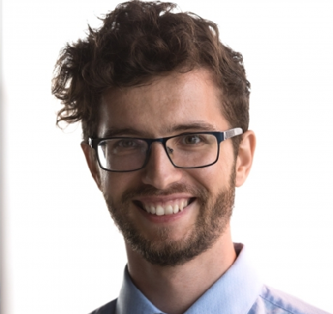

B.A. in Business Administration, University of North Carolina at Charlotte, 2018 NMLS registration, active and in good standing
EDUCATION

