P&L Management Menu Engineering
KEY SKILLS
Vendor Contract Negotiation Toast POS
Partender
7Shifts
FIFO Rotation
State and Local Alcohol Service Requirements
Staff Scheduling Cocktail Development HACCP Principles
Developed 27 cocktail menu items over 2 years, collaborating with kitchen teams on garnish presentation and seasonal ingredient sourcing.
- Scheduled and received weekly deliveries for all 3 locations, verifying product quality and quantity against purchase orders within 45 minutes per site.
- Negotiated annual contracts with 7 spirit and wine distributors, securing volume pricing that saved $11,830 across the portfolio in 2024.
- Bar Manager, Pemigewasset Falls Tavern, Plymouth, NH
2016 – 2020

  - Built a cross-training rotation on food prep stations for 12 bartenders and set up flexible shift swaps through 7Shifts.
  - Created 14 seasonal cocktail recipes per year, tracking sales velocity in Toast POS and retiring items that sold fewer than 8 units per week.
  - Scheduled staff hours for a team of 12, assigning opening, mid, and closing duties while keeping overtime under 6 hours per person each pay period.
  - Monitored portion sizes and garnish presentation during service, conducting nightly line checks to confirm drink builds matched spec cards.

- Lead Bartender, Squam Lake Brewing Company, Holderness, NH
2014 – 2016

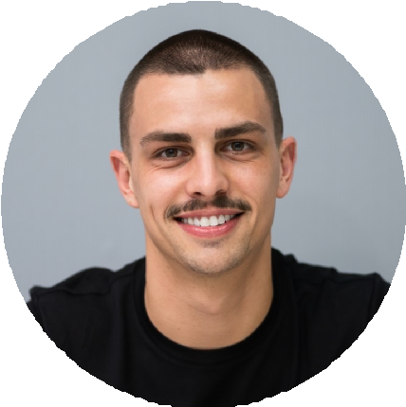



BA Tourism Management and Policy Plymouth State University, Plymouth, NH 2010 – 2014
Adrian Keller
Beverage Director
Beverage professional with 12 years of experience overseeing cocktail
development, vendor negotiations, and multi-location bar operations. Lowered annual staff turnover from 44% to 29.3% through a structured mentorship program and one-on-one reviews, and negotiated distributor contracts that saved $11,830 across the portfolio in 2024. Holds a TIPS Certification and a BA in Tourism Management and Policy, with daily proficiency in Toast POS, Partender, and 7Shifts.
PROFESSIONAL EXPERIENCE
Beverage Director, Winnisquam Shore Hospitality Group, Laconia, NH
2020 – Present

Oversee beverage programs across 3 bar locations, standardizing recipes, vendor terms, and training protocols to maintain consistent quality at each property.
Lowered annual staff turnover from 44% to 29.3% by creating a 90-day
mentorship program and scheduling biweekly one-on-one reviews with each bartender.
EDUCATION

(603) 555-0132

adrian.keller@example.com Laconia, NH 12345
CONTACT INFORMATION
  - Contributed 9 original cocktail recipes to the spring and fall seasonal menus, with 4 items remaining on rotation for over 18 months.
  - Counted and logged inventory for 132 SKUs at close using Partender, flagging reorder items 3 days before projected stockout dates.
  - Verified delivery contents against invoices for biweekly shipments, rejecting an average of 2 items per order that fell below quality standards.

CERTIFICATIONS

TIPS Certification, Health Communications, Inc., 2015

