Zoe Petrovic

Senior Group Fitness Instructor

Group fitness instructor with 6 years of experience teaching HIIT, cycling, BOSU balance training, and free-weight circuits while providing nutrition and lifestyle counseling. Grew class rosters and acquired 60 new members across two facilities, and managed a $73,100 annual program budget covering equipment replacement, sound system maintenance, and promotional materials. Holds an ACE Group Fitness Instructor Certification and a BS in Exercise Science.

Contact information

(507) 555-0111

zoe.petrovic@example.com Winona, MN 12345

Education
BS IN EXERCISE SCIENCE | WINONA STATE UNIVERSITY, WINONA, MN | 2016 - 2020

Professional experience
SENIOR GROUP FITNESS INSTRUCTOR | BLUFFSIDE ATHLETIC CLUB, WINONA, MN | 2023 - PRESENT

Acquired 37 new members in Q1 2025 by launching a 6-week HIIT trial-class series promoted through community outreach events.
Organized 3 wellness challenges per quarter, each running 4 weeks and averaging 28 participants per challenge cycle.
Instructed participants on maintaining target heart-rate zones using heart-rate monitors, growing average class size from 19 to 34 participants.
Provided one-on-one guidance on nutrition, weight control, and lifestyle modiﬁcations during post-class ofﬁce hours for 47 members each month.

Key skills
HIIT Programming
TRX Suspension Training BOSU Balance Training Spin / Cycling Instruction Heart-Rate Zone Coaching Free-Weight Circuit Design
Nutrition and Lifestyle Counseling
Class Scheduling
Sound System Operation Microsoft Ofﬁce
GROUP FITNESS INSTRUCTOR | COULEE VALLEY RECREATION CENTER, LA CROSSE, MN | 2021 - 2023

Recruited 23 new members over 8 months by introducing a Saturday morning cycling boot camp that averaged 31 participants per session.
Organized 2 wellness challenges each quarter, coordinating weigh-ins and progress tracking for up to 44 participants per challenge.
Observed participants during free-weight circuits and coached corrective form adjustments, keeping the program at zero overuse injuries across 14 months.
Managed a $73,100 annual program budget covering equipment replacement, sound system maintenance, and promotional materials.

FITNESS INSTRUCTOR | ROOT RIVER COMMUNITY GYM, RUSHFORD, MN | 2020 - 2021

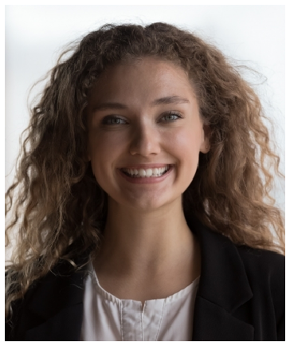



Built class rosters from 11 to 26 participants within 5 months by adding a BOSU balance-training session each Wednesday evening.
Acquired 14 new members over the ﬁrst year by leading free introductory classes at local park events.
Educated participants on post-workout recovery nutrition and hydration strategies, distributing printed resource guides to 83 attendees over 9 months.

Certifications
ACE Group Fitness Instructor Certiﬁcation, American Council on Exercise | 2020

