Sandra Nilsson
Junior 3D Artist

Entry-level 3D artist with 2 years of experience building game-ready and VR assets in Autodesk Maya, Blender, and Substance Painter. Reduced application load time by 19.2% for a VR product demo by optimizing mesh density and baking normal maps, and built 73 3D assets including props, UI elements, and environmental objects across 9 months of studio production.

CONTACT INFORMATION
PROFESSIONAL EXPERIENCE
Junior 3D Artist | Catoctin Ridge Interactive, Frederick, MD
2025 - Present

(301) 555-0118
sandra.nilsson@exam ple.com
Frederick, MD 12345

KEY SKILLS
- Reduced application load time by 19.2% for a VR product demo by optimizing mesh density and baking normal maps in Substance Painter, cutting average scene load from 8.3 seconds to 6.7 seconds.
- Built 73 3D assets including props, UI elements, and environmental objects in Autodesk Maya over 9 months, averaging 8 deliverables per month.
- Grew the studio reusable asset library from 31 to 84 models by tagging, organizing, and documenting modular pieces for re-use across 3 active projects.

  - Autodesk Maya
  - Blender
  - Created pen-and-paper concept sketches for 14 product label illustrations, scanning and reﬁning them into textured 3D renders for client review within 48-hour turnarounds.

  - Substance Painter
  - Jira
3D Art Intern | Monocacy Bluff Studios, Hagerstown, MD
2024 - 2025

  - UV Unwrapping
  - Low-Poly Modeling
  - Normal Map Baking
  - Texture Painting
  - 3D Asset Pipeline
  - Mesh Optimization
  - Produced 54 game-ready 3D assets in Blender for a mobile puzzle title, maintaining polygon counts under 4,200 triangles per object to meet mobile performance budgets.
  - Maintained conﬁguration control for 217 asset ﬁles using Jira tickets and folder naming conventions, keeping version conﬂicts to fewer than 2 per sprint.
  - Drafted illustrations and design drawings for 6 product carton mockups, translating 2D concepts into 3D packaging visualizations within 3-day cycles.

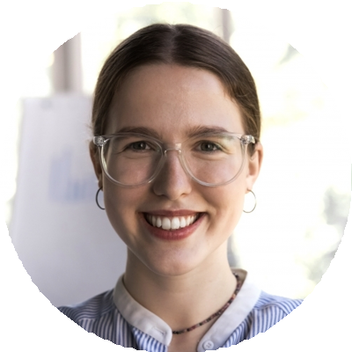



EDUCATION
BS in Emerging Media
Frostburg State University, Frostburg, MD | 2020 - 2024

