Percy Calloway
3D Artist

Versatile 3D artist with 6 years of experience contributing environment, prop, and character assets to 7 feature ﬁlms across VFX and animation departments. Accelerated asset delivery speed by 23.7% by building template scenes in Autodesk Maya with pre-conﬁgured shading networks, and skilled in Substance Painter, V-Ray, Blender, and ZBrush.

Contact Information

(231) 555-0125
percy.calloway@example.c om
Traverse City, MI 12345

Education

BS in Digital Animation and Game Design
Ferris State University, Big Rapids, MI
2016 - 2020

Key Skills

Autodesk Maya Blender ZBrush
Substance Painter V-Ray
UV Unwrapping and Layout
Jira
Hard-Surface Modeling Character Modeling Texture Baking
nCloth Simulation

Professional Experience

3D Artist | 2023 - Present
Torch Lake Visual Works, Traverse City, MI

Contributed to 5 feature ﬁlms across VFX and animation departments, delivering environment and prop assets on schedule for theatrical releases with combined budgets over $71.4M.
Accelerated asset delivery speed by 23.7% by building template scenes in Autodesk Maya with pre-conﬁgured shading networks, cutting average asset turnaround from 3.8 days to 2.9 days.
Scripted, planned, and created 14 animated narrative sequences under 2-week deadlines, coordinating background design, camera blocking, and lighting passes with the director.
Reduced production time on hero character turntables from 9 hours to 6 hours 48 minutes by consolidating V-Ray shader graphs and automating render-layer setup.

3D Artist | 2021 - 2023
Leelanau Dune Studios, Suttons Bay, MI

Contributed environment assets to 2 feature ﬁlms in post-production, modeling 47 set extensions in Maya that matched on-set reference photography within 0.4-inch tolerance.
Improved asset delivery speed by 22.8% for a 16-week VFX schedule by batching UV layouts and texture exports in Substance Painter, saving 1.5 days per asset cycle.
Participated in production coordination for 3 multimedia campaigns, tracking budgets totaling $4,870 in material costs and delivering all milestones within 48 hours of target dates.
Simulated cloth and hair behavior on 11 character models using Maya nCloth, validating motion against reference footage frame by frame before compositing handoff.
Junior 3D Artist | 2020 - 2021
Crystal River Animation, Cadillac, MI


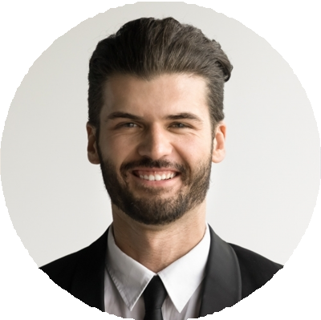



Modeled and textured 63 production-ready props in Blender over 11 months, maintaining delivery pace of 6 assets per week during peak sprint weeks.
Cut production time on background plate renders by 16.7% by reorganizing scene hierarchies and replacing duplicated geometry with instanced references.
Used rigid-body simulations to preview destruction sequences for 8 animated shots, reducing director feedback rounds from 4 days to 2 days per shot.

