Olga Mukherjee

Psychiatric Registered Nurse

Psychiatric registered nurse with 6 years of experience across locked adult, subacute, and behavioral health inpatient units, holding a Psychiatric-Mental Health Nursing Certiﬁcation. Reduced adverse incidents on the unit from 9 to 6 per quarter by standardizing suicide risk screening protocols and hourly safety rounds. Performs suicide risk screenings, psychotropic medication administration, and multidisciplinary care coordination on units of up to 30 beds.

Hays, KS 12345

(785) 555-0111

olga.mukherjee@example.co m

KEY SKILLS
- Psychiatric Nursing Process
- Suicide Risk Screening Tools
- De-escalation Techniques
- Psychotropic Medication Administration
- EHR Documentation
- Vital Signs Monitoring
- HIPAA Compliance
PROFESSIONAL EXPERIENCE

PSYCHIATRIC REGISTERED NURSE | SALINE VALLEY BEHAVIORAL HEALTH CENTER, HAYS, KS
2023 – PRESENT
- Manage a daily patient caseload of 23 on a 30-bed locked adult psychiatric unit, coordinating medication rounds, risk screenings, and treatment updates with psychiatrists and social workers.
- Reduced adverse incidents on the unit from 9 to 6 per quarter by standardizing suicide risk screening protocols and hourly safety rounds.
- Complete 57 monthly client assessments using structured interviews and EHR-based templates, tracking symptom trends and updating individualized interventions.
- Administer psychotropic medications via oral and IV injection routes, monitoring for side effects and documenting responses within 45 minutes of each dose.

- Multidisciplinary Care Coordination
- Crisis Intervention
- Phlebotomy
PSYCHIATRIC NURSE | CHEYENNE BLUFF COMMUNITY HOSPITAL, WAKEENEY, KS
2021 – 2023

CERTIFICATIONS
- Carried a daily patient caseload of 16 across a 24-bed subacute psychiatric unit, performing intake screenings and collaborating with outpatient providers on discharge transitions.

  - Registered Nurse License, State board of nursing, 2020
  - National Council Licensure Examination for Registered
Nurses, National Council of State Boards of Nursing, 2020
  - Introduced a structured shift-change handoff process and real-time EHR flagging for high-risk patients on a 24-bed subacute unit.
  - Completed 43 monthly client assessments, documenting mental status exams, behavioral observations, and medication efficacy for
the treatment team.

  - Psychiatric-Mental Health Nursing Certification, American
Nurses Credentialing Center, 2022
REGISTERED NURSE - BEHAVIORAL HEALTH | PRAIRIE RIDGE MEDICAL GROUP, GREAT BEND, KS
2020 – 2021



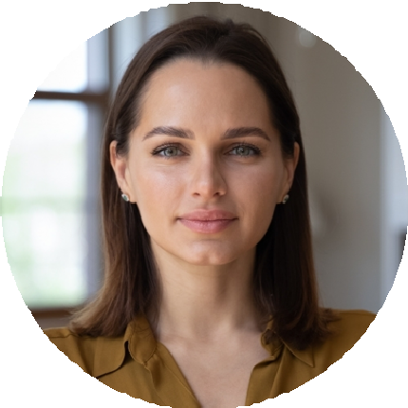
  - Nonviolent Crisis Intervention Training, Crisis Prevention
Institute, 2021
  - Basic Life Support, American Heart Association, 2026
  - Managed a daily patient caseload of 12 on a 20-bed behavioral health floor, conducting vital signs monitoring and de-escalation
interventions during each 12-hour shift.
  - Reduced adverse incidents from 11 per quarter to 8 per quarter within the first 9 months by co-developing a fall-prevention checklist
for sedated patients.

    - Completed 34 monthly client assessments under supervising RN guidance, entering findings into the EHR within 2 hours of each patient encounter.

    - Bachelor of Science in Nursing
EDUCATION
Fort Hays State University, Hays, KS | 2016 – 2020

