Joaquin Holloway
Director of Coaching
Experienced in organizing over 37 youth events per year across 9 age groups, while directing curriculum alignment for 6 staff coaches and guiding players toward collegiate scholarships. At a prior club, increased program participation by 18.1% over 3 seasons by introducing a recreational pathway that fed into the competitive track. Holds SafeSport Trained certiﬁcation and 11 years of progressive coaching leadership.
PROFESSIONAL EXPERIENCE

C O N T A C T
I N F O R M A T I O N

(765) 555-0132

joaquin.holloway@example.com Muncie, IN
2021 - Present
Director of Coaching | White River Youth Soccer Association, Muncie, IN

Organized 37 youth events per year, including training camps, preseason tryouts, and skill clinics serving over 340 participants across 9 age groups.
Guided 8 players to Division I and Division II scholarships over 4 seasons by building recruitment portfolios and coordinating college coach contacts.
Grew total program participation from 189 to 237 registrants in 2 years by restructuring age-group offerings and adding a spring development league.
Set club-wide coaching methodology for 6 staff coaches, conducting monthly 90-minute curriculum alignment meetings to maintain consistency across all teams.

K E Y S K I L L S
2018 - 2021
Head Coach | Cardinal Creek Soccer Club, Anderson, IN

Sportscode Hudl
US Soccer Grassroots Pathway NFHS Coaching Standards
Player Recruitment Pipeline Development
Age-Group Curriculum Design Tournament Planning Microsoft Ofﬁce
Staff Mentorship Tryout Organization
Arranged and led 14 youth events per season, including 4 invitational tournaments and 10 skill-improvement clinics for U-12 through U-18 players.
Helped 3 senior players secure college scholarships by compiling highlight reels from Hudl ﬁlm and scheduling campus visits with 7 university programs.
Increased program participation by 18.1% over 3 seasons by introducing a recreational pathway that fed into the competitive track.
Instructed groups of up to 26 athletes in positional movement, set-piece execution, and small-sided tactical concepts during 5 weekly training sessions.

2015 - 2018
Assistant Coach | Yorktown Athletic Club, Yorktown, IN

Planned and ran 11 preseason and in-season youth events, including tryout days and holiday clinics that drew 85 to 120 participants each.
Reviewed 3 opponent matches per week using Sportscode to tag attacking patterns, then presented tactical adjustments to the head coach before game day.
Coordinated travel logistics for a 22-player roster, conﬁrming bus schedules, ﬁeld assignments, and parent communication an average of 6 days ahead of departure.




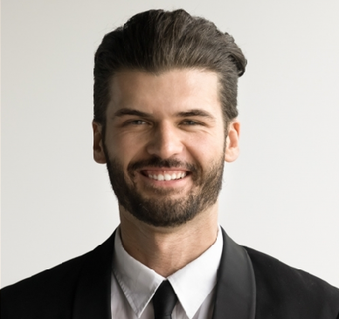
EDUCATION
BS, Exercise Science
Ball State University, Muncie, IN | 2011 - 2015
CERTIFICATIONS

SafeSport Trained, U.S. Center for SafeSport, 2026

