Stellan Yilmaz

Senior 3D Artist

Experienced in character, environment, and creature modeling across film VFX pipelines using Autodesk Maya, ZBrush, Substance Painter, and V-Ray over 12 years of studio work. Delivered hero assets for theatrical VFX films that earned a combined $247M in box-office revenue while raising team productivity by 12.9% through standardized scene templates and naming conventions.

Contact information

(507) 555-0132

stellan.yilmaz@example.com Winona, MN 12345

Education
BA IN ART | WINONA STATE UNIVERSITY, WINONA, MN | 2010 - 2014

Key skills
Autodesk Maya ZBrush Substance Painter V-Ray
Blender Jira
UV Layout and Unwrapping
Character and Environment Modeling
Texture Baking and Material Workﬂows
Art Direction

Professional experience
SENIOR 3D ARTIST | BLUFF COUNTRY DIGITAL, WINONA, MN | 2021 - PRESENT

Delivered hero environment and creature assets for 2 theatrical VFX ﬁlms that earned a combined $247M in box-ofﬁce revenue, completing all assigned sequences 4 days ahead of ﬁnal deadline.
Raised team productivity by 12.9% across an 8-artist modeling unit by standardizing scene templates and naming conventions in Autodesk Maya, reducing daily ﬁle-search overhead by 22 minutes per person.
Mentored 6 junior artists on sculpting anatomy and hard-surface techniques, conducting weekly 90-minute critiques that shortened their average ramp-up period from 11 weeks to 7 weeks.
Created two-dimensional storyboard frames and three-dimensional previsualization sequences for 9 action scenes, giving directors camera-blocking options 6 days before principal photography.

3D ARTIST | IRON RANGE MOTION ARTS, ROCHESTER, MN | 2017 - 2021

Produced character and prop assets for a VFX-heavy feature that grossed
$89.4M at the worldwide box ofﬁce, modeling 31 hero props and 14 set pieces across a 9-month schedule.
Boosted team productivity by 16.8% during a 12-week crunch by authoring 7 reusable ZBrush custom brush kits that eliminated repetitive sculpting steps for organic detail passes.
Illustrated process-driven animations depicting ﬂuid dynamics and particle effects for 4 promotional trailers, rendering ﬁnal frames in V-Ray at 4K resolution within 48-hour delivery windows.
Developed technical illustrations and turntable renders for 18 product brochures, converting concept sketches into textured 3D models in under 3 days per asset.

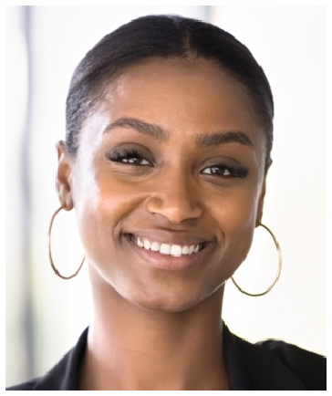




JUNIOR 3D ARTIST | PRAIRIE HOLLOW STUDIOS, LA CROSSE, WI | 2014 - 2017

Modeled and textured environment props for a streaming-original ﬁlm that earned $38.9M in domestic theatrical and digital release revenue, delivering 42 assets on a 14-week timeline.
Cut texture iteration time from 4 hours to 2 hours 47 minutes per asset by building a shared Substance Painter preset library of 53 smart materials, boosting the team's weekly output by 9 ﬁnished textures.
Created two-dimensional layout illustrations and three-dimensional motion sequences for 6 multimedia presentations used in client pitch meetings, winning 3 new contracts worth a combined $9,150.

