Dalia Fairbanks

Senior Medical Scribe

C O N T A C T I N F O R M A T I O N

(302) 555-0111

dalia.fairbanks@example.com Smyrna, DE 12345

E D U C A T I O N

BS, Health Sciences
University of Delaware, Newark, DE 2016 - 2020

K E Y S K I L L S

Epic (EHR charting)
Cerner (patient data management) ICD-10 coding
CPT coding Medical terminology HIPAA compliance Microsoft Word
Clinical workﬂow coordination Real-time transcription
Chart quality review

A B O U T M E
Certified Professional Medical Scribe (AAPC) with 6 years of experience documenting patient encounters in Epic and Cerner across urgent care and outpatient settings. Reduced physician after-hours documentation workload by 28.2% by pre-populating review-of-systems and history fields in Epic before each encounter. Mentored new scribes, performed real-time transcription at 74 WPM, and cross-referenced ICD-10 and CPT codes to minimize addendum requests.

P R O F E S S I O N A L E X P E R I E N C E
Senior Medical Scribe | 2023 - Present
Murderkill Creek Medical Associates, Smyrna, DE
Maintained a typing speed of 74 WPM during live patient encounters, enabling real-time transcription of physician dictation across 37 exam rooms per shift.
Reduced physician after-hours documentation workload by 28.2% by pre-populating review-of-systems and history fields in Epic before each encounter.
Lowered addendum requests from 2.8 to 0.4 per chart by implementing a same-visit verification step with the attending before chart closure.
Mentored 4 new scribes on encounter-flow documentation, cutting their average onboarding period from 6 weeks to 19 days.
Medical Scribe | 2021 - 2023
Leipsic Bay Health Group, Dover, DE
Documented an average of 34 patient encounters daily in Cerner, capturing chief complaints, exam findings, and procedure notes in under 4 minutes per chart.
Completed discharge summaries and referral letters within 90 seconds of each encounter close.
Cross-referenced ICD-10 and CPT codes against physician verbal orders before submission.
Medical Scribe | 2020 - 2021
Broadkill River Urgent Care, Milford, DE
Achieved a sustained typing speed of 68 WPM while scribing for 2 urgent care physicians handling up to 41 patients per shift.
Drafted procedure notes, wound-care documentation, and lab-order entries in Epic, averaging 3 minutes 42 seconds per completed chart.
Flagged 7 medication-interaction alerts per week during real-time documentation, prompting physician review before prescription finalization.

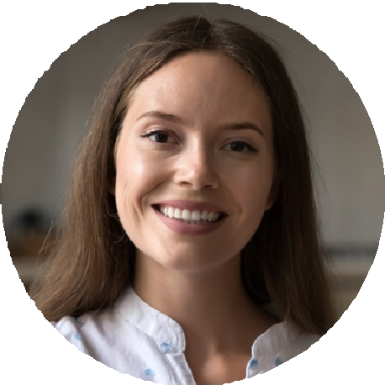




C E R T I F I C A T I O N S
Certified Professional Medical Scribe, AAPC | 2021

