Divya Shah
Nurse Educator Specialist

Registered Nurse with 6 years of experience designing simulation-based training programs and competency evaluations across medical-surgical units. Raised staff competency improvement scores by 22.12% across 3 units and restructured skills-checklist workflows in Relias and Canvas to cut evaluation turnaround times. Holds an MSN in Nursing Education and an active Registered Nurse license.

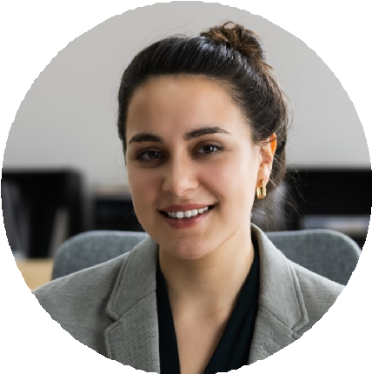




CONTACT INFORMATION

(256) 555-0111

divya.shah@example.com Albertville, AL 12345

EDUCATION

MSN Nursing Education
University of Alabama in Huntsville, Huntsville, AL
2018 – 2020

Bachelor of Science Nursing University of Alabama in Huntsville, Huntsville, AL
2014 – 2018

KEY SKILLS

Simulation Lab Equipment Competency Gap Analysis Curriculum Design Canvas
Relias
Adult Learning Principles Clinical Skills Assessment OBRA Requirements
OSHA Bloodborne Pathogens Standard
Staff Orientation Planning

PROFESSIONAL EXPERIENCE
Nurse Educator Specialist, Flint River Regional Medical Center, Albertville, AL
2023 – Present

Facilitated 27 simulation scenarios covering cardiac arrest, sepsis, and medication error response for 174 nursing staff using simulation lab equipment.
Reduced competency evaluation turnaround from 11 days to 4 days by restructuring the skills-checklist workflow in Relias learning system.
Raised staff competency improvement scores by 22.12% across 3 medical-surgical units within the first 9 months.
Prepare and deliver pharmacology and community health lectures to groups of 18 to 24 nurses per cohort each quarter.

Staff Nurse Educator, Sand Mountain Health Partners, Boaz, AL
2021 – 2023

Facilitated 14 simulation scenarios per year for new graduate nurses, improving staff competency evaluation pass rates from 81.02% to 97.98%.
Shortened competency evaluation turnaround to 6 days by creating standardized rubrics and tracking records in Canvas.
Maintained attendance records, grades, and clinical evaluation files for 87 nursing staff across 4 departments.
Registered Nurse, Cherokee Bluff Community Hospital, Fort Payne, AL
2020 – 2021

Precepted 9 new hires and coached each through a 42-day orientation period, contributing to a 16.14% improvement in unit-wide competency scores.
Documented patient assessments and care plans in the electronic health records system for an average of 6 patients per shift.
Evaluated and graded clinical assignments for 4 nursing students during practicum rotations each semester.

CERTIFICATIONS
Registered Nurse, State Board of Nursing, 2018

