Wade Guerrero
Auto Claims Adjuster

A B O U T M E

C O N TA C T
I N F O R M AT I O N

(352) 555-0111

wade.guerrero@example.co m

Ocala, FL 12345

E D U C AT I O N
Bachelor of Science in Business Administration in Finance | University of Central Florida, Orlando, FL | 2016 - 2020

K E Y S K I L L S
CCC ONE
Claims management software ISO policy forms
Liability investigation Settlement negotiation
Fair claims practices regulations Subrogation recovery
Microsoft Excel
Bodily injury evaluation Reserve analysis
Bringing 6 years of auto claims experience and an Associate in Claims credential, with deep skill in liability investigation, bodily injury evaluation, and settlement negotiation using CCC ONE. Currently managing a claims portfolio valued at $7.1M while reducing average claim processing cost from $1,150 to $970 per ﬁle by consolidating vendor referrals and standardizing documentation workﬂows.
P R O F E S S I O N A L E X P E R I E N C E
AUTO CLAIMS ADJUSTER | WITHLACOOCHEE RIVER INSURANCE GROUP, OCALA, FL
2023 - PRESENT

Maintain 163 policyholder contacts per month through proactive outreach, status updates, and settlement discussions on a caseload of 158 open ﬁles.
Manage a claims portfolio valued at $7.1M, reviewing police reports, medical records, and repair estimates to determine liability on each ﬁle.
Reduced average claim processing cost from $1,150 to $970 per ﬁle by consolidating vendor referrals and standardizing documentation workﬂows.
Examine claims forms, coverage declarations, and ISO policy forms to conﬁrm coverage applicability before authorizing payments.

CLAIMS ADJUSTER | SILVER SPRINGS MUTUAL INSURANCE, GAINESVILLE, FL
2021 - 2023

Coordinated with claimants, repair shops, and medical providers on each open ﬁle, logging every contact in the claim notes within 24 hours.
Oversaw a portfolio of $4.3M in open claim reserves, prioritizing severe-exposure ﬁles for early resolution.
Moved routine claimant correspondence to claims management software templates, cutting letter drafting time from 25 minutes to 10 minutes per ﬁle.
Reviewed medical treatment records and billing statements on bodily injury claims to evaluate settlement ranges within 48 hours of receipt.

CLAIMS REPRESENTATIVE | SUWANNEE BEND CASUALTY CO., LAKE CITY, FL
2020 - 2021

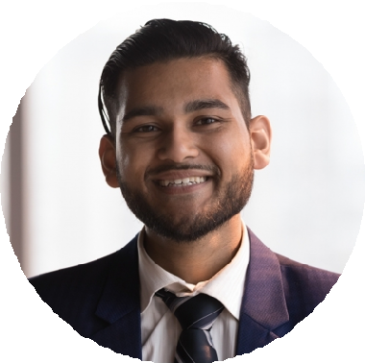



Contacted an average of 87 policyholders per month to gather loss details, explain coverage, and set expectations on claim timelines.
Resolved complex, severe-exposure auto claims using high-service ﬁle handling, keeping average cycle time at 26 days.
Reviewed physical property damage photos and repair invoices in CCC ONE to verify estimate accuracy before approving payments.
C E R T I F I C AT I O N S
RESIDENT ALL-LINES ADJUSTER LICENSE (6-20), FLORIDA DEPARTMENT OF FINANCIAL SERVICES | FLORIDA DEPARTMENT OF FINANCIAL SERVICES | 2020
ASSOCIATE IN CLAIMS | THE INSTITUTES | 2022

