Miguel Bergman

Senior Accountant

Accounting professional with 12 years of experience spanning invoice processing, bank statement reconciliation, and general ledger management using SAP, QuickBooks, and Excel. Standardizing tie-out procedures and adding secondary review checkpoints in SAP reduced account reconciliation discrepancies by 45.50% across 48 balance sheet accounts. Directs a team of staff accountants, maintaining a 98.22% accuracy rate across sub-ledgers through structured task assignment and work paper reviews.

Contact information

(580) 555-0132

miguel.bergman@example.com Ardmore, OK 12345

Education
BSBA IN ACCOUNTING | OKLAHOMA STATE UNIVERSITY, STILLWATER, OK | 2010 - 2014

Key skills
SAP
Microsoft Excel QuickBooks
Account Reconciliation General Ledger Management Accounts Payable
Invoice Processing
Bank Statement Reconciliation SQL
Financial Reporting

Professional experience
SENIOR ACCOUNTANT | WASHITA CREEK HOLDINGS LLC, ARDMORE, OK | 2020 - PRESENT

Reduced account reconciliation discrepancies by 45.50% across 48 balance sheet accounts by standardizing tie-out procedures and adding secondary review checkpoints in SAP.
Reviewed and processed an average of 274 invoices per month, verifying coding accuracy and resolving $15,470 in duplicate payment ﬂags per quarter.
Reconciled 36 bank statements monthly for operating and payroll accounts, clearing an average of 87 outstanding items within 5 business days.
Directed a team of 3 staff accountants, assigning reconciliation tasks and reviewing work papers to maintain a 98.22% accuracy rate across sub-ledgers.

STAFF ACCOUNTANT | ARBUCKLE VALLEY SERVICES INC., DAVIS, OK | 2017 - 2020

Reviewed and processed 870 invoices per month in SAP, matching purchase orders and receiving documents before routing for approval.
Reconciled 22 bank statements monthly, identifying and resolving an average of 43 discrepancies per cycle within 4 business days.
Reduced account reconciliation discrepancies from 6.04% to 3.82% on intercompany accounts by creating a shared tracking log between two regional ofﬁces.

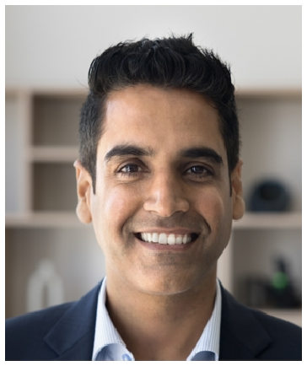




ACCOUNTING CLERK | BLUE RIVER PRAIRIE CO-OP, DURANT, OK | 2014 - 2017

Processed 540 vendor invoices per month, matching receipts to purchase orders and entering line-item data into QuickBooks.
Reconciled 14 bank statements monthly, ﬂagging an average of 29 unmatched transactions for supervisor review within 3 business days.
Organized and ﬁled 2,180 source documents per quarter to support year-end audit preparation.

