BEATRICE SALAZAR

Digital Sculptor
Bath, ME 12345 | (207) 555-0111 | beatrice.salazar@example.com

Professional Experience
Digital Sculptor
Kennebec Ledge Interactive, Bath, ME | 2023 - Present

Autodesk Certiﬁed User in Maya with 6 years of experience sculpting characters, environment props, and game-ready 3D assets using ZBrush and Autodesk Maya. Improved asset quality ratings by 36.6% across 4 game environments by rebuilding sculpting and retopology workﬂows in ZBrush. Skilled in storyboarding, UV unwrapping, optical scanning cleanup, and cross-functional collaboration with animators, riggers, lighting artists, and VFX teams.

ZBrush Autodesk Maya
Substance Painter
UV Unwrapping and Retopology Jira
Character Sculpting Storyboarding
Hard-Surface Modeling Optical Scanning Cleanup Texture Painting
Improved asset quality ratings by 36.6% across 4 game environments by rebuilding sculpting and retopology workﬂows in ZBrush, raising average review scores from 56 to 76.5 on a 100-point internal rubric.
Coordinated with 9 cross-functional teams including animators, lighting artists, riggers, and sound designers to align character models with narrative direction across 3 concurrent sprints.
Profile
Saved 3 revision cycles per character project by presenting layered sculpt variants to art directors during early blockout reviews, cutting feedback loops from 14 days to 5 days.
Converted real-world architectural elements to game-ready 3D props using optical scanning and ZBrush cleanup, delivering 37 assets in 8 weeks.
3D Artist
Sheepscot Valley Studios, Wiscasset, ME | 2021 - 2023

Collaborated with 7 cross-functional teams spanning UI, VFX, and marketing to deliver cohesive visual styles for 2 product launches on schedule.
Key Skills
Built annotated storyboards that mapped camera angles and lighting cues for each environment asset before sculpting began.
Designed 23 complex character models in Maya, applying independent creative direction to meet art-lead speciﬁcations within 6-day turnaround windows.
Proposed a revised UV unwrapping approach for hero assets, cutting texture stretching ﬁxes from 9 to 2 per asset.
Junior 3D Modeler
Androscoggin Peak Media, Lewiston, ME | 2020 - 2021

Modeled 34 environment props and set pieces in Maya for a mobile adventure title, averaging 4 completed assets per week across 2 milestone sprints.
Collaborated with 5 cross-functional teams to ensure models matched concept art silhouettes within 48 hours of brieﬁng.
Created storyboard sequences for 11 animated cutscenes, mapping scene ﬂow and character blocking for director review.


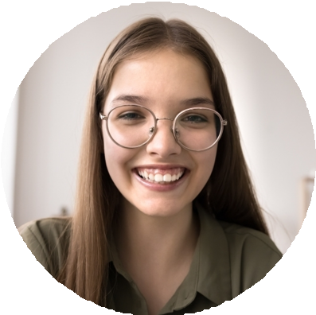

Education
BFA in Animation and Game Art
Maine College of Art and Design, Portland, ME | 2016 - 2020

Certifications
Autodesk Certiﬁed User in Maya, Autodesk, 2021

