Hiro Quinlan

Night Concierge

Multilingual hospitality professional with 6 years of experience providing overnight guest services, errand coordination, and ADA accommodation across properties of up to 142 rooms. Improved evening-shift service efficiency by 22.11% after consolidating errand pickup routes and batching guest deliveries. Holds a Certified Guest Service Professional credential and fluency in English, Spanish, and French.

Contact Information

(318) 555-0111

NIGHT CONCIERGE | CANE RIVER BOUTIQUE HOTEL, NATCHITOCHES, LA 2023 – PRESENT
Professional Experience

hiro.quinlan@example.com Natchitoches, LA 12345

Key Skills
- VIP Guest Relations
- Local Area Knowledge
- ADA Accommodation Requests
- Serve guests in 3 languages (English, Spanish, and French), handling VIP dining and tour reservations for a 142-room property without interpreter
delays.
- Reduced overnight check-in wait time from 7 minutes to 3 minutes 40 seconds by pre-staging registration packets and coordinating room-ready
status with housekeeping.
- Provide tailored information on local dining, nightlife, and recreational destinations, maintaining an updated directory of 87 venues.
- Arrange wheelchair loans, rollaway beds, and ADA-compliant room swaps within an average of 9 minutes per request.

  - Multi-line Phone System
  - Microsoft Outlook
CONCIERGE | BAYOU BEND INN AND SUITES, ALEXANDRIA, LA 2021 – 2023

  - Errand Coordination
  - Conflict Resolution
  - Cross-Department Communication
  - Spanish Fluency
  - French Fluency
  - Improved evening-shift service efficiency by 22.11% after consolidating errand pickup routes and batching guest deliveries into 45-minute cycles.
  - Picked up and delivered prescriptions, dry cleaning, and packages for guests, completing an average of 14 errands per shift.
  - Guided Spanish-speaking guests through local shopping and dining options, cutting average inquiry time from 6 minutes to 3 minutes 15
seconds.

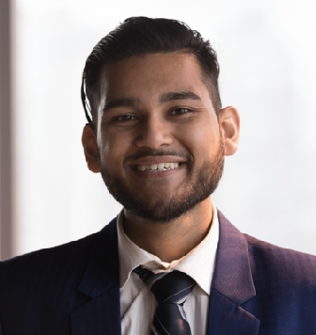


GUEST SERVICES AGENT | KISATCHIE LODGE, LEESVILLE, LA 2020 – 2021
    - Processed guest arrivals and departures using a multi-line phone system and Microsoft Outlook, averaging 47 check-ins per evening shift.
    - Shortened lobby wait times by 13 seconds per guest after reorganizing key-card encoding and folio printing steps.
    - Assisted guests with special needs by coordinating wheelchair availability and accessible-room assignments across 3 floors.
Education

BS in Hospitality Management | University of Louisiana at Lafayette
Lafayette, LA | 2016 – 2020
Certifications

- Certified Guest Service Professional, American Hotel & Lodging Educational Institute, 2021

